
Menoufia National University
Faculty of Computers and Artificial Intelligence Program of Internet of Things and Big Data Analytics

AI-Powered Home Security System

Prepared by:
Omar Mahmoud AbdElhakim Gomaa
Mohammad Ataa Mohammad Elbassal
AbdElrahman Ateff Farag Ahmad
Yousef Ibrahim Mohammad Mahmoud
Mahmoud Mohammad Abdelfatah Mohammad

Supervised by:
Dr. Elhossiny Ibrahim

A Project Thesis Submitted to the Faculty of Computers and Artificial Intelligence in Partial Fulfillment of the requirements for the Award of the Degree of Bachelor of Computers and Artificial Intelligence of Menoufia National University.

Academic Year 2025 - 2026

Examination Committee

The graduation project [AI-Powered Home Security System] By
Omar Mahmoud AbdElhakim Gomaa
Mohammad Ataa Mohammad Elbassal
AbdElrahman Ateff Farag Ahmad
Yousef Ibrahim Mohammad Mahmoud
Mahmoud Mohammad Abdelfatah Mohammad

was evaluated and approved by the following committee:

Name Signature

(Supervisor)

(Internal Examiner)

(External Examiner)
Dedication

we dedicate this work to our parents, teachers, and friends who supported us throughout our journey.

Acknowledgments
First and foremost, we thank Allah for granting us the strength, patience, and ability to complete this work.

We would like to express our deepest gratitude to our supervisor, Dr. Elhossiny Ibrahim, for their invaluable guidance, continuous support, and constructive feedback throughout every stage of this project. Their expertise and encouragement were fundamental to the success of this work.

We extend our sincere thanks to the faculty members and staff of the Faculty of Computers and Artificial Intelligence at Menoufia National University for providing us with the knowledge, skills, and academic environment that made this project possible.

We are also grateful to the developers and communities behind the open-source tools and platforms used in this project, including Google Firebase, Flutter, the Python ecosystem, HiveMQ, Cloudinary, and the PlatformIO community, whose freely available resources and documentation greatly facilitated our development process.

Finally, we owe our deepest appreciation to our families and friends for their unconditional love, patience, and moral support throughout our academic journey. Their belief in us was a constant source of motivation.

Abstract

List of FiguresAbstract

List of FiguresAbstract

List of FiguresAbstract

List of FiguresAbList of Tablesf List of Algorithmsist ReferencesAbstract

List of FiguresAbstract

List of FiguresAbstract

List of FiguresAbstract

List of FiguresAbstract

List of FiguresAbstract

List of FiguresAbList of Tablesf List of Algorithmsist ReferencesAbstract

List of FiguresAbstract

List of FiguresAbstract

List of FiguresAbstract

List of FiguresAbstract

List of FiguresAbstract

List of FiguresAbList of Tablesf List of Algorithmsist ReferencesAbstract

List of FiguresAbstract

List of FiguresAbstract

List of FiguresAbstract

List of FiguresAbstract

List of FiguresAbstract

List of FiguresAbList of Tablesf List of Algorithmsist ReferencesAbstract

List of FiguresAbstract

List of FiguresAbstract

List of FiguresAbstract

List of FiguresAbstract

List of FiguresAbstract

List of FiguresAbList of Tablesf List of Algorithmsist ReferencesAbstract

List of FiguresAbstract

List of FiguresAbstract

List of FiguresAbstract

List of FiguresAbstract

List of FiguresAbstract

List of FiguresAbList of Tablesf List of Algorithmsist ReferencesAbstract

List of FiguresAbstract

List of FiguresAbstract

List of FiguresAbstract

List of FiguresAbstract

List of FiguresAbstract

List of FiguresAbList of Tablesf List of Algorithmsist ReferencesAbstract

List of FiguresAbstract

List of FiguresAbstract

List of FiguresAbstract

List of FiguresAbstract

List of FiguresAbstract

List of FiguresAbList of Tablesf List of Algorithmsist ReferencesAbstract

List of FiguresAbstract

List of FiguresAbstract

List of FiguresAbstract

List of FiguresAbstract

List of FiguresAbstract

List of FiguresAbList of Tablesf List of Algorithmsist ReferencesAbstract

List of FiguresAbstract

List of FiguresAbstract

List of FiguresAbstract

List of FiguresAbstract

List of FiguresAbstract

List of FiguresAbList of Tablesf List of Algorithmsist ReferencesAbstract

List of FiguresAbstract

List of FiguresAbstract

List of FiguresAbstract

List of FiguresAbstract

List of FiguresAbstract

List of FiguresAbList of Tablesf List of Algorithmsist ReferencesAbstract

List of FiguresAbstract

List of FiguresAbstract

List of FiguresAbstract

List of FiguresAbstract

List of FiguresAbstract

List of FiguresAbList of Tablesf List of Algorithmsist ReferencesAbstract

List of FiguresAbstract

List of FiguresAbstract

List of FiguresAbstract

List of FiguresAbstract

List of FiguresAbstract

List of FiguresAbList of Tablesf List of Algorithmsist ReferencesAbstract

List of FiguresAbstract

List of FiguresAbstract

List of FiguresAbstract

List of FiguresAbstract

List of FiguresAbstract

List of FiguresAbList of Tablesf List of Algorithmsist ReferencesAbstract

List of FiguresAbstract

List of FiguresAbstract

List of FiguresAbstract

List of FiguresAbstract

List of FiguresAbstract

List of FiguresAbList of Tablesf List of Algorithmsist ReferencesAbstract

List of FiguresAbstract

List of FiguresAbstract

List of FiguresAbstract

List of FiguresAbstract

List of FiguresAbstract

List of FiguresAbList of Tablesf List of Algorithmsist ReferencesAbstract

List of FiguresAbstract

List of FiguresAbstract

List of FiguresAbstract

List of FiguresAbstract

List of FiguresAbstract

List of FiguresAbList of Tablesf List of Algorithmsist ReferencesAbstract

List of FiguresAbstract

List of FiguresAbstract

List of FiguresAbstract

List of FiguresAbstract

List of FiguresAbstract

List of FiguresAbList of Tablesf List of Algorithmsist ReferencesAbstract

List of FiguresAbstract

List of FiguresAbstract

List of FiguresAbstract

List of FiguresAbstract

List of FiguresAbstract

List of FiguresAbList of Tablesf List of Algorithmsist ReferencesAbstract

List of FiguresAbstract

List of FiguresAbstract

List of FiguresAbstract

List of FiguresAbstract

List of FiguresAbstract

List of FiguresAbList of Tablesf List of Algorithmsist ReferencesAbstract

List of FiguresAbstract

List of FiguresAbstract

List of FiguresAbstract

List of FiguresAbstract

List of FiguresAbstract

List of FiguresAbList of Tablesf List of Algorithmsist ReferencesAbstract

List of FiguresAbstract

List of FiguresAbstract

List of FiguresAbstract

List of FiguresAbstract

List of FiguresAbstract

List of FiguresAbList of Tablesf List of Algorithmsist ReferencesAbstract

List of FiguresAbstract

List of FiguresAbstract

List of FiguresAbstract

List of FiguresAbstract

List of FiguresAbstract

List of FiguresAbList of Tablesf List of Algorithmsist ReferencesAbstract

List of FiguresAbstract

List of FiguresAbstract

List of FiguresAbstract

List of FiguresAbstract

List of FiguresAbstract

List of FiguresAbList of Tablesf List of Algorithmsist ReferencesAbstract

List of FiguresAbstract

List of FiguresAbstract

List of FiguresAbstract

List of FiguresAbstract

List of FiguresAbstract

List of FiguresAbList of Tablesf List of Algorithmsist ReferencesAbstract

List of FiguresAbstract

List of FiguresAbstract

List of FiguresAbstract

List of FiguresAbstract

List of FiguresAbstract

List of FiguresAbList of Tablesf List of Algorithmsist ReferencesAbstract

List of FiguresAbstract

List of FiguresAbstract

List of FiguresAbstract

List of FiguresAbstract

List of FiguresAbstract

List of FiguresAbList of Tablesf List of Algorithmsist ReferencesAbstract

List of FiguresAbstract

List of FiguresAbstract

List of FiguresAbstract

List of FiguresAbstract

List of FiguresAbstract

List of FiguresAbList of Tablesf List of Algorithmsist ReferencesAbstract

List of FiguresAbstract

List of FiguresAbstract

List of FiguresAbstract

List of FiguresAbstract

List of FiguresAbstract

List of FiguresAbList of Tablesf List of Algorithmsist ReferencesAbstract

List of FiguresAbstract

List of FiguresAbstract

List of FiguresAbstract

List of FiguresAbstract

List of FiguresAbstract

List of FiguresAbList of Tablesf List of Algorithmsist ReferencesAbstract

List of FiguresAbstract

List of FiguresAbstract

List of FiguresAbstract

List of FiguresAbstract

List of FiguresAbstract

List of FiguresAbList of Tablesf List of Algorithmsist ReferencesAbstract

List of FiguresAbstract

List of FiguresAbstract

List of FiguresAbstract

List of FiguresAbstract

List of FiguresAbstract

List of FiguresAbList of Tablesf List of Algorithmsist ReferencesAbstract

List of FiguresAbstract
Home security has become an increasingly critical concern in modern society, with traditional surveillance systems lacking intelligent analysis capabilities and real-time remote accessibility.

This project presents the design and implementation of an AI-Powered Home Security System that integrates computer vision, artificial intelligence, cloud services, and IoT hardware into a unified, real-time security platform.

The system consists of two main components: a Python-based desktop application that runs on a PC connected to a surveillance camera, and a Flutter-based cross-platform mobile application for Android and iOS. The desktop application continuously captures video, streams it live to the mobile app via an encrypted MQTT channel, and periodically analyzes frames using Google Gemini 2.5 Flash to detect anomalies, identify known family members through facial recognition, and detect threats such as intruders, weapons, or suspicious behavior.

Upon detecting an anomaly, the system automatically uploads a snapshot to Cloudinary, sends a Firebase Cloud Messaging (FCM) push notification to the user's mobile device, stores the alert in a Firestore database, and optionally triggers a physical hardware alarm. The mobile application allows users to view the live encrypted video stream, review the history of AI-generated security alerts, and remotely control paired IoT hardware devices including gate locks and alarm systems.

The system employs end-to-end Fernet symmetric encryption for the video stream, TLS-secured MQTT communication, and Firebase Authentication for user identity management. Evaluation results demonstrate that the system achieves reliable real-time performance with low latency video streaming and accurate AI-based threat detection.

Keywords: Home Security, IoT, Artificial Intelligence, Computer Vision, MQTT, Firebase, Flutter, Gemini AI, Real-time Surveillance, Face Recognition.

Table of Contents
Abstract III
List of Figures VI
List of Tables VII
List of Algorithms 10
Chapter 1: Introduction 11
1.1 Background 11
1.2 Problem Statement 11
1.3 Research Objectives 12
1.4 Significance and Motivation 13
1.5 Scope and Organization 13
Chapter 2: Literature Review Background 14
2.1 Overview 14
2.2 Existing Competitors 15
2.3 Background Concepts 15
Chapter 3: Methodology 17
3.1 Research Design 17
3.2 Software Development Life Cycle (SDLC) Model 17
3.3 Requirements Analysis 17
3.4 System Design 19
3.5 Implementation Details 19
3.6 Testing Strategy 20
3.7 Data Collection and Analysis 20
Chapter 4: System Design and Architecture 21
4.1 System Architecture 21
4.2 Database Design 22
4.3 User Interface Design 27
Chapter 5: Implementation 39
5.1 Development Environment 39
5.2 Key Functionalities 40
5.3 Implementation Challenges 44
Chapter 6: Testing and Evaluation 48
6.1 Test Plan 48
6.2 Test Cases 49
6.3 Test Results 50
6.4 Evaluation Metrics 52
6.5 User Acceptance Testing (UAT) 53
Chapter 7: Results and Discussion 54
7.1 Summary of Results 54
7.2 Discussion and Analysis 55
7.3 Limitations 56
Chapter 8: Deployment 58
8.1 Deployment Strategy 58
8.2 Deployment Environment 59
8.3 Installation and Configuration 60
8.4 Release Management 62
8.5 Monitoring and Logging 63
8.6 Maintenance and Support Plan 64
Chapter 9: Conclusion and Future Work 66
9.1 Conclusions 66
9.2 Future Work 67
References 70
Appendix A 71
A.1 Code Listings 71
A.2 User Manuals 72
A.3 Raw Data 73

List of Figures

Figure | Title | Page
Figure 1.1 | High-Level System Overview | Ch. 1
Figure 2.1 | MQTT Publish-Subscribe Architecture | Ch. 2
Figure 2.2 | Fernet Symmetric Encryption and Decryption Flow | Ch. 2
Figure 2.3 | Firebase Platform Services Used in the System | Ch. 2
Figure 3.1 | Agile Development Sprints and Deliverables | Ch. 3
Figure 3.2 | System Three-Tier Architecture | Ch. 3
Figure 4.1 | Complete System Architecture Diagram | Ch. 4
Figure 4.2 | Communication Channels Between System Components | Ch. 4
Figure 4.3 | Firestore Database Collections and Documents Schema | Ch. 4
Figure 4.4 | Mobile Application Main Screen Layout | Ch. 4
Figure 4.5 | Mobile Application Screen Hierarchy and Navigation Flow | Ch. 4
Figure 4.6 | Home Screen UI Design | Ch. 4
Figure 4.7 | Hardware Control Screen UI Design | Ch. 4
Figure 4.8 | Notification Screen UI Design | Ch. 4
Figure 5.1 | Video Recording and Automatic Chunk Splitting Flow | Ch. 5
Figure 5.2 | Encrypted Live Video Streaming Pipeline | Ch. 5
Figure 5.3 | AI Anomaly Detection Workflow Using Gemini API | Ch. 5
Figure 5.4 | Gemini API Multimodal Prompt Structure | Ch. 5
Figure 5.5 | QR Code Pairing Sequence Diagram | Ch. 5
Figure 5.6 | Hardware Remote Control Flow via Firebase | Ch. 5
Figure 5.7 | Push Notification Pipeline from Detection to Mobile | Ch. 5
Figure 5.8 | Family Reference Image Caching Mechanism | Ch. 5
Figure 6.1 | Test Cases Pass/Fail Summary | Ch. 6
Figure 6.2 | Stream Latency Measurements Across Test Runs | Ch. 6
Figure 6.3 | AI Response Time Measurements Across Test Runs | Ch. 6
Figure 6.4 | Notification Delivery Time Measurements Across Test Runs | Ch. 6
Figure 7.1 | AI Detection Accuracy by Scenario | Ch. 7
Figure 7.2 | False Positive Rate vs Target Threshold | Ch. 7
Figure 7.3 | System Performance Metrics Summary | Ch. 7
Figure 8.1 | Hybrid Deployment Architecture | Ch. 8
Figure 8.2 | Mobile Application Installation Steps | Ch. 8
Figure 8.3 | ESP32 Hardware Deployment and Configuration Steps | Ch. 8

Table | Title | Page
Table 2.1 | Comparison of Existing Home Security Systems | Ch. 2
Table 3.1 | Functional Requirements | Ch. 3
Table 3.2 | Non-Functional Requirements | Ch. 3
Table 4.1 | Communication Channels Between System Components | Ch. 4
Table 5.1 | Mobile Application Development Environment and Tools | Ch. 5
Table 5.2 | ESP32 Hardware Development Environment and Tools | Ch. 5
Table 5.3 | Cloud Services and Their Purposes | Ch. 5
Table 6.1 | Test Cases and Results | Ch. 6
Table 6.2 | System Evaluation Metrics — Target vs Measured | Ch. 6
Table 7.1 | AI Detection Accuracy by Scenario | Ch. 7
Table 8.1 | Cloud Services Configuration | Ch. 8
Table A.1 | Stream Latency and Notification Delivery Measurements | Appendix A
Table A.2 | AI Detection Accuracy Raw Data | Appendix A

List of Tables

Algorithm | Title | Page
Algorithm 1 | Device Credentials Load or Generate | Ch. 5
Algorithm 2 | Video Recording with Thread-Safe Frame Sharing | Ch. 5
Algorithm 3 | Automatic Recording Chunk Splitting | Ch. 5
Algorithm 4 | Encrypted Live Video Streaming Worker | Ch. 5
Algorithm 5 | Family Reference Image Cache with Signature Detection | Ch. 5
Algorithm 6 | AI Frame Analysis with Concurrent Thread Pool | Ch. 5
Algorithm 7 | Gemini Multimodal Prompt Construction | Ch. 5
Algorithm 8 | Anomaly Response Handler — Upload, Notify, and Alarm | Ch. 5
Algorithm 9 | FCM Push Notification with Invalid Token Cleanup | Ch. 5
Algorithm 10 | Hardware Alarm Trigger via Firestore Command Queue | Ch. 5
Algorithm 11 | QR Code Generation for Device Pairing | Ch. 5
Algorithm 12 | MQTT Connection Setup with TLS | Ch. 5
Algorithm 13 | Live Stream Frame Decryption and Display (Flutter) | Ch. 5
Algorithm 14 | Hardware State Real-Time Listener (Flutter) | Ch. 5
Algorithm 15 | FreeRTOS Task Initialization and Queue Creation | Ch. 5
Algorithm 16 | DHT22 Sensor Monitoring Task | Ch. 5
Algorithm 17 | Gate Control Task with Servo and Buzzer | Ch. 5
Algorithm 18 | Buzzer Task — Short Beep and Alarm Mode | Ch. 5
Algorithm 19 | Firebase State Upload to Firestore | Ch. 5
Algorithm 20 | Firebase Command Polling and Execution | Ch. 5

List of Algorithms

Chapter 1: Introduction

Background
The rapid advancement of Internet of Things (IoT) technologies, cloud computing, and artificial intelligence has opened new possibilities for intelligent home automation and security systems. Traditional surveillance systems rely on passive video recording that requires manual review, making them reactive rather than proactive. Homeowners increasingly demand systems that can autonomously detect threats, recognize familiar individuals, and deliver instant alerts all accessible remotely from a smartphone.

The convergence of affordable single-board computers, high-quality webcams, cloud-based AI inference APIs, and real-time messaging protocols makes it feasible to build sophisticated security systems without expensive proprietary hardware. This project leverages these technologies to create a fully integrated, intelligent home security platform that combines live video surveillance, AI-powered anomaly detection, facial recognition of family members, IoT hardware control, and real-time mobile notifications.

Problem Statement
Existing home security solutions suffer from several limitations:

- Passive recording only: Most consumer-grade systems record footage but do not analyze it in real time, requiring users to manually review hours of video after an incident.
- No intelligent differentiation: Systems cannot distinguish between a known family member arriving home and an unknown intruder, leading to false alarms or missed threats.
- Limited remote control: Many systems offer basic live viewing but lack the ability to remotely control physical security hardware such as gate locks and alarm systems.
- Lack of integration: Video streaming, notifications, hardware control, and alert history are typically handled by separate, disconnected applications.
- Security vulnerabilities: Many consumer IoT cameras transmit video without encryption, making them susceptible to interception.
This project addresses all of these limitations through a unified, AI-driven, end-to-end encrypted security platform.

Research Objectives
The primary objectives of this project are:

- Design and implement a real-time video surveillance desktop application capable of capturing, recording, and streaming live video from a connected camera.

- Integrate Google Gemini 2.5 Flash AI to perform intelligent frame analysis including anomaly detection, threat classification, and family member facial recognition.

- Develop a secure, encrypted live video streaming pipeline using MQTT over TLS with Fernet symmetric encryption.

- Build a cross-platform Flutter mobile application enabling users to view live streams, receive AI-generated push notifications, and control IoT hardware remotely.

- Implement a Firebase-based backend for user authentication, real-time data synchronization, push notification delivery, and hardware command routing.

- Design a QR-code-based device pairing mechanism for seamless and secure camera and hardware registration.

- Integrate Cloudinary for cloud-based storage of alert snapshots linked to security notifications.

Significance and Motivation
- Personal safety: Provides homeowners with an intelligent, always-on security layer that can detect and respond to threats faster than any human monitoring service.
- Accessibility: By delivering alerts and controls through a standard smartphone application, the system is accessible to non-technical users without specialized equipment.

- Academic contribution: Demonstrates the practical integration of multiple cutting-edge technologies multimodal AI, IoT, real-time messaging, and cloud services within a single cohesive system.

- Cost-effectiveness: Runs on commodity hardware (a standard PC with a webcam) and uses free-tier or low-cost cloud services, making it affordable for typical households.

- Privacy and security: End-to-end encryption of the video stream ensures that surveillance footage cannot be intercepted by third parties.

Scope and Organization

Scope: This project covers the design, implementation, and testing of a home security system consisting of a Python desktop surveillance station and a Flutter mobile application. The system supports a single household with one or more cameras and IoT hardware devices.

The system includes three main components: a Python desktop surveillance application, a Flutter cross-platform mobile application, and an ESP32-based IoT hardware device whose firmware is fully implemented and documented in this thesis.

Organization: Chapter 2 reviews existing solutions and background technologies. Chapter 3 describes the methodology. Chapter 4 presents the system design. Chapter 5 covers implementation. Chapter 6 presents testing results. Chapter 7 discusses results. Chapter 8 covers deployment. Chapter 9 concludes and outlines future work.

Chapter 2: Literature Review Background

Overview
Intelligent surveillance and home security systems have been an active area of research and commercial development for over two decades. Early systems focused on motion-triggered recording and remote viewing via proprietary applications. The emergence of deep learning, particularly Convolutional Neural Networks (CNNs), enabled significant advances in object detection, face recognition, and activity classification within video streams.

More recently, large multimodal AI models have made it possible to perform complex scene understanding, including identifying specific individuals, detecting weapons, and assessing behavioral context from a single image frame without requiring specialized training datasets.

Simultaneously, the IoT ecosystem has matured with standardized communication protocols such as MQTT enabling lightweight, low-latency messaging between devices. Cloud platforms like Firebase provide scalable real-time databases, authentication services, and push notification infrastructure that can be integrated into mobile applications with minimal backend development effort.

Existing Competitors
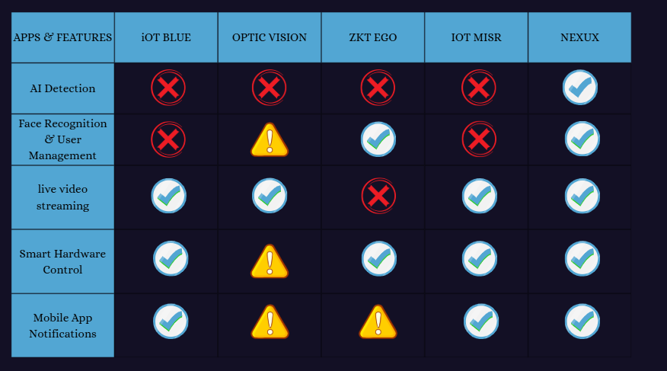
Differentiation of this project: Unlike commercial solutions, this system uses a general-purpose multimodal AI (Gemini 2.5 Flash) that can recognize specific family members by name using reference photos without any model training. It also provides end-to-end encrypted video streaming, full source code transparency, and operates on commodity hardware without proprietary devices or mandatory subscriptions.

Background Concepts

2.3.1 MQTT Protocol
Message Queuing Telemetry Transport (MQTT) is a lightweight publish-subscribe messaging protocol designed for constrained devices and low-bandwidth networks. It uses a broker-based architecture where publishers send messages to topics and subscribers receive them. In this project, MQTT streams encrypted video frames from the desktop to the mobile application via HiveMQ Cloud over TLS on port 8883.

2.3.2 Firebase Platform
Firebase is Google's mobile and web application development platform providing Firestore (a NoSQL real-time document database), Firebase Authentication (supporting email/password and OAuth providers), and Firebase Cloud Messaging (FCM) for cross-platform push notifications. Firestore's real-time listener capability is used for live hardware state updates and notification delivery.

2.3.3 Fernet Symmetric Encryption
Fernet is a symmetric authenticated encryption scheme based on AES-128-CBC with HMAC-SHA256 for authentication. It guarantees that data encrypted with a given key cannot be decrypted or tampered with without that key. Each camera device generates a unique Fernet key shared with the mobile app exclusively via QR code scan.

2.3.4 Google Gemini 2.5 Flash
Gemini 2.5 Flash is Google's multimodal large language model capable of processing both text and images in a single inference call. This project uses it as a zero-shot security analyst: given reference photos of family members and a surveillance frame, it identifies known individuals by name and detects anomalies without any custom model training.

2.3.5 Flutter Framework
Flutter is Google's open-source UI toolkit for building natively compiled applications for mobile, web, and desktop from a single Dart codebase. This project uses Flutter for the mobile application targeting Android and iOS with Material Design 3.

2.3.6 Cloudinary
Cloudinary is a cloud-based media management platform providing image upload, storage, transformation, and delivery via CDN. It stores alert snapshots captured during anomaly detection events and profile/family member photos used for AI reference.

Chapter 3: Methodology

Research Design
This project follows an applied engineering research design. The primary goal is to build a functional, integrated system that solves a real-world problem. The design process was driven by functional requirements gathered from analysis of existing home security system limitations, followed by iterative prototyping and integration of individual components.

Software Development Life Cycle (SDLC) Model
The project adopted an Agile iterative development model with four main sprints:
- Sprint 1: Core video recording and MQTT streaming pipeline with encryption.
- Sprint 2: Firebase integration — authentication, Firestore data model, FCM notifications.
- Sprint 3: AI detector integration with Gemini API, Cloudinary upload, hardware alarm triggering.
- Sprint 4: Flutter mobile application — live stream viewer, notification screen, hardware control, QR pairing.

Requirements Analysis

Functional Requirements
ID | Requirement
FR-01 | The system shall capture live video from a connected camera at up to 1280×720 resolution.
FR-02 | The system shall record video to local storage in AVI format, split into 5-minute chunks.
FR-03 | The system shall stream live video to the mobile app in real time with end-to-end encryption.
FR-04 | The system shall analyze video frames using AI to detect anomalies every 5 seconds.
FR-05 | The AI shall identify known family members by name using reference photos.
FR-06 | The system shall send push notifications to the user's mobile device upon anomaly detection.
FR-07 | The system shall upload alert snapshots to cloud storage and include them in notifications.
FR-08 | The system shall trigger a hardware alarm for medium or high severity threats.
FR-09 | The mobile app shall display the live encrypted video stream.
FR-10 | The mobile app shall display a history of AI-generated security alerts with images.
FR-11 | The mobile app shall allow remote control of gate and alarm hardware.
FR-12 | The mobile app shall support QR-code-based pairing of cameras and hardware devices.
FR-13 | The system shall support user registration and login via email/password and Google Sign-In.
FR-14 | Users shall be able to manage family member profiles with reference photos for AI recognition.

Non-Functional Requirements
ID | Requirement
NFR-01 | Video stream latency shall not exceed 2 seconds under normal network conditions.
NFR-02 | All video data transmitted over the network shall be encrypted using Fernet + TLS.
NFR-03 | The system shall handle up to 10 concurrent AI analysis requests without blocking the UI.
NFR-04 | The mobile application shall be compatible with Android 8.0+ and iOS 13+.
NFR-05 | The desktop application shall run on Windows 10+ with Python 3.10+.
NFR-06 | The system shall automatically split recordings to prevent individual files exceeding 5 minutes.

System Design
The system follows a three-tier architecture:
- Presentation Tier: PyQt6 desktop GUI and Flutter mobile application.

- Logic Tier: Python modules for recording, streaming, AI analysis, and notification dispatch.

- Data Tier: Firebase Firestore, Cloudinary, and HiveMQ Cloud.

Implementation Details
- Desktop: Python 3.x, PyQt6, OpenCV, paho-mqtt, cryptography (Fernet), google-genai, firebase-admin, cloudinary, qrcode, pillow.

- Mobile: Flutter (Dart), firebase_core/auth/firestore/messaging, mqtt_client, encrypt, mobile_scanner, flutter_local_notifications, cloudinary_sdk, google_sign_in.

- Hardware: ESP32 DOIT DevKit V1, programmed using the Arduino framework via PlatformIO. Libraries used: FirebaseClient (mobizt) for Firestore communication, ESP32Servo for servo motor control, DHT sensor library for temperature and humidity readings, and NTPClient for timestamp generation.

Testing Strategy
- Unit Testing: Individual modules tested in isolation (CryptoManager, VideoRecorder, AIDetector).

- Integration Testing: End-to-end tests verified encrypted stream delivery and Firestore command routing.

- System Testing: Full scenario tests simulating family detection, intruder detection, and hardware alarm triggering.

Data Collection and Analysis
System performance was evaluated by measuring stream latency, AI detection accuracy, notification delivery time, and false positive rate across multiple test runs under realistic network conditions.

Chapter 4: System Design and Architecture

System Architecture

The system architecture consists of three interconnected layers. The Smart Hardware layer includes CCTV cameras and sensors responsible for live video streaming, face recognition, and lock control, all connected through an encrypted channel to ensure secure data transmission. The Mobile Application serves as the central control interface, allowing the home user to send commands such as lock and buzzer control, view the live video feed, manage family members for face recognition, and receive real-time alerts and notifications. The Backend and Cloud layer is built on Firebase and HiveMQ (Beehive) handling authentication, device communication, notification delivery, and user management, supported by Cloudinary for storing captured images and the Gemini API for AI-powered anomaly detection and suspicious activity analysis.

Communication Channels

Channel | Protocol | Security | Purpose
Live video stream | MQTT over TCP | TLS + Fernet | Real-time frame delivery
Push notifications | FCM (HTTPS) | Firebase TLS | Anomaly alerts to mobile
Alert history & state | Firestore WebSocket | Firebase TLS | Real-time data sync
Hardware commands | Firestore WebSocket | Firebase TLS | Remote device control
Alert images | HTTPS (Cloudinary CDN) | TLS | Snapshot storage & delivery
Device pairing | QR Code (local) | Physical proximity | Key & config exchange

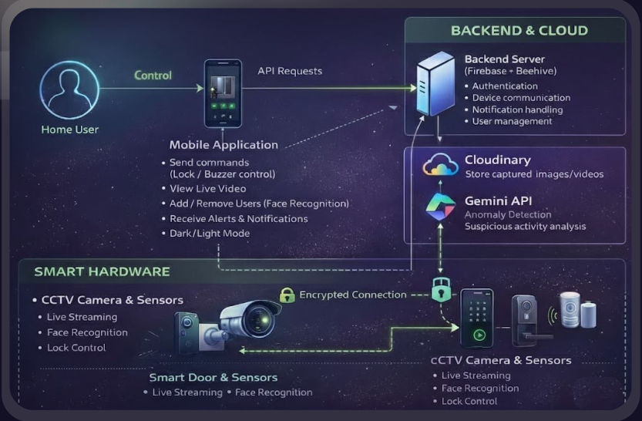

Database Design

The system uses Firebase Firestore as its primary database, a cloud-hosted NoSQL document database that supports real-time data synchronization across all connected clients. Firestore organizes data into collections and documents, making it well-suited for the hierarchical structure of this system where each user owns a set of cameras, hardware devices, notifications, and family member profiles.

The database is structured around two top-level collections: Users and Hardware, as described below.

Users Collection

The Users collection stores all data related to registered users of the mobile application. Each document is identified by the user's Firebase Authentication UID and contains the following fields and sub-collections.

User Document Fields

Field | Type | Description
name | String | Full name of the user
email | String | Email address
phone | String | Phone number
profileImageUrl | String | Cloudinary URL of profile photo
fcmTokens | Array | Firebase Cloud Messaging tokens for push notifications

Sub-collection: cameras
Stores configuration data for each paired surveillance camera.

Field | Type | Description
name | String | User-assigned camera name
device_id | String | Unique device identifier
key | String | Fernet encryption key (Base64 encoded)
mqtt_topic | String | MQTT topic for the video stream
broker | String | MQTT broker hostname
port | Number | MQTT broker port (typically 8883)
username | String | MQTT authentication username
password | String | MQTT authentication password

Sub-collection: hardware
Stores configuration data for each paired IoT hardware device.

Field | Type | Description
name | String | User-assigned device name
device_id | String | Unique hardware device identifier

Sub-collection: notifications
Stores the history of AI-generated security alerts.

Field | Type | Description
title | String | Alert title
body | String | Detailed anomaly description
pushBody | String | Short summary sent in push notification
imageUrl | String | Cloudinary URL of the captured alert snapshot
timestamp | Timestamp | Server-generated time of the alert
read | Boolean | Indicates whether the user has read the notification

Sub-collection: family_members
Stores reference photos of family members used by the AI for facial recognition.

Field | Type | Description
name | String | Family member name
imageUrl | String | Cloudinary URL of the reference photo

Hardware Collection

The Hardware collection manages the state and command queue of all paired IoT devices. Each document is identified by the hardware device ID and contains two sub-collections.

Sub-collection: states
Published by the ESP32 firmware every 5 seconds to report the current physical state of the device.

Field | Type | Description
state | String | Device connectivity status ("Online" / "Offline")
temperature | Number | Current temperature reading from DHT22 sensor (°C)
humidity | Number | Current humidity reading from DHT22 sensor (%)
gate | Boolean | Current gate position (true = Open, false = Closed)
alarm_state | Boolean | Current alarm state (true = Active, false = Off)
timestamp | String | ISO 8601 timestamp of the state reading

Sub-collection: commands
Written by the mobile application or the desktop AI detector to send control instructions to the hardware device. The ESP32 polls this collection every 3 seconds, executes the command, then deletes the document.

Field | Type | Description
command | String | Command type: "SET_GATE" or "SET_ALARM"
params | Map | Command parameters: {"state": "OPEN"/"CLOSE"/"ON"/"OFF"}
triggered_by | String | UID of the user or system that issued the command
timestamp | Timestamp | Server-generated time of the command

Design Justification
Firestore was selected over a traditional relational database for the following reasons:
- Real-time synchronization: Firestore's snapshot listeners allow the mobile app to reflect hardware state changes and new notifications instantly without polling.
- Scalability: The document model scales horizontally without schema migrations, allowing new fields to be added to any document without affecting existing records.
- Serverless integration: Firestore integrates natively with Firebase Authentication and Firebase Cloud Messaging, eliminating the need for a custom backend server.
- Offline support: Firestore's built-in offline persistence ensures the mobile app remains functional during brief network interruptions.

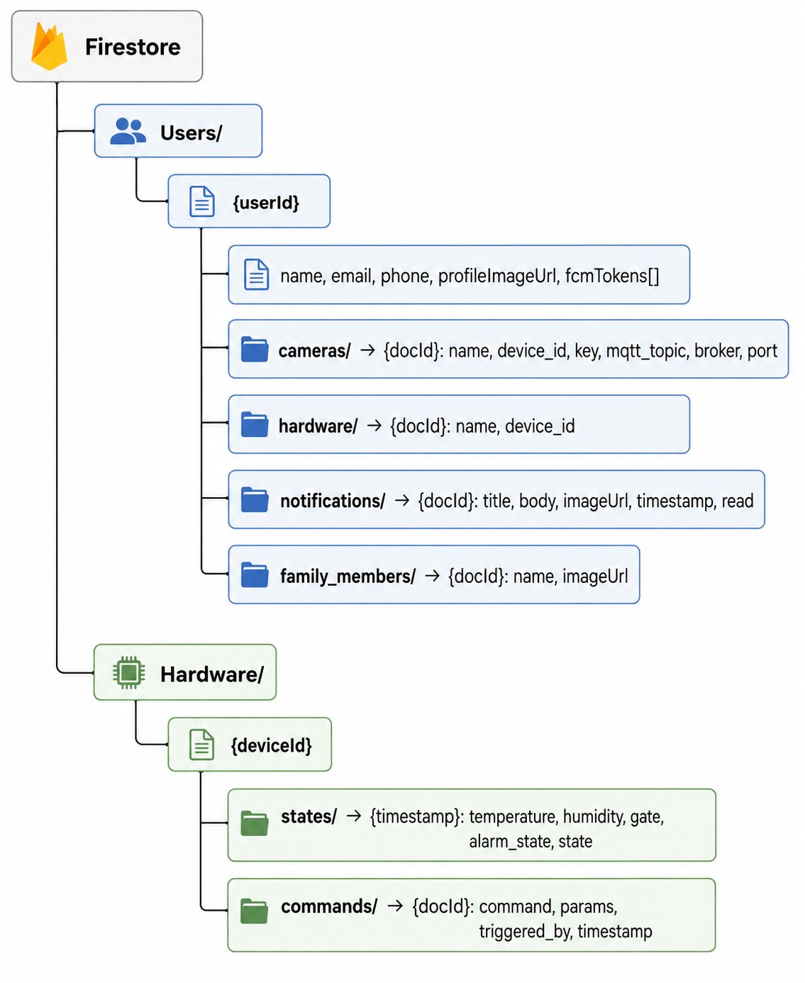

User Interface Design

Desktop Main Window
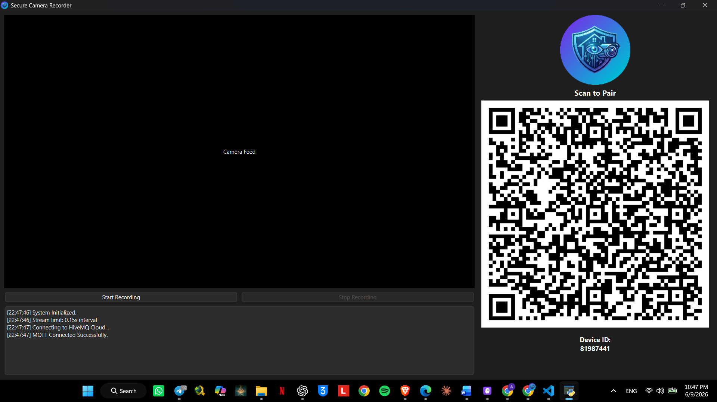

Desktop QR Code
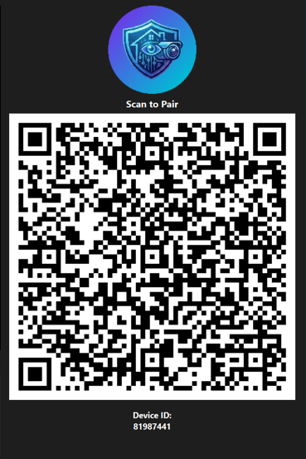

Splash Screen

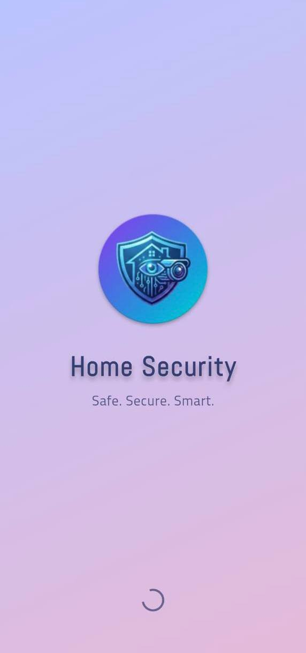

Login Screen

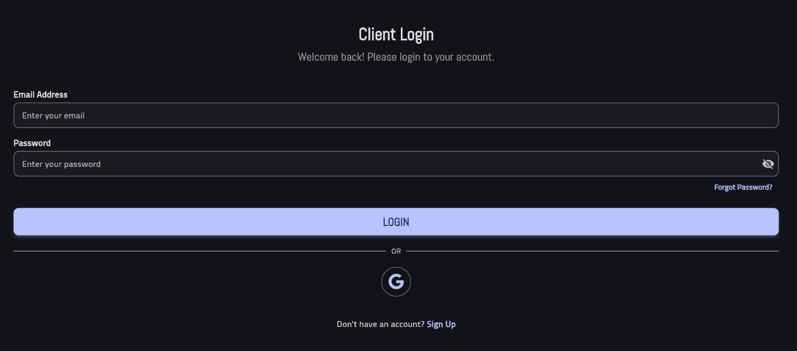

Signup Screen

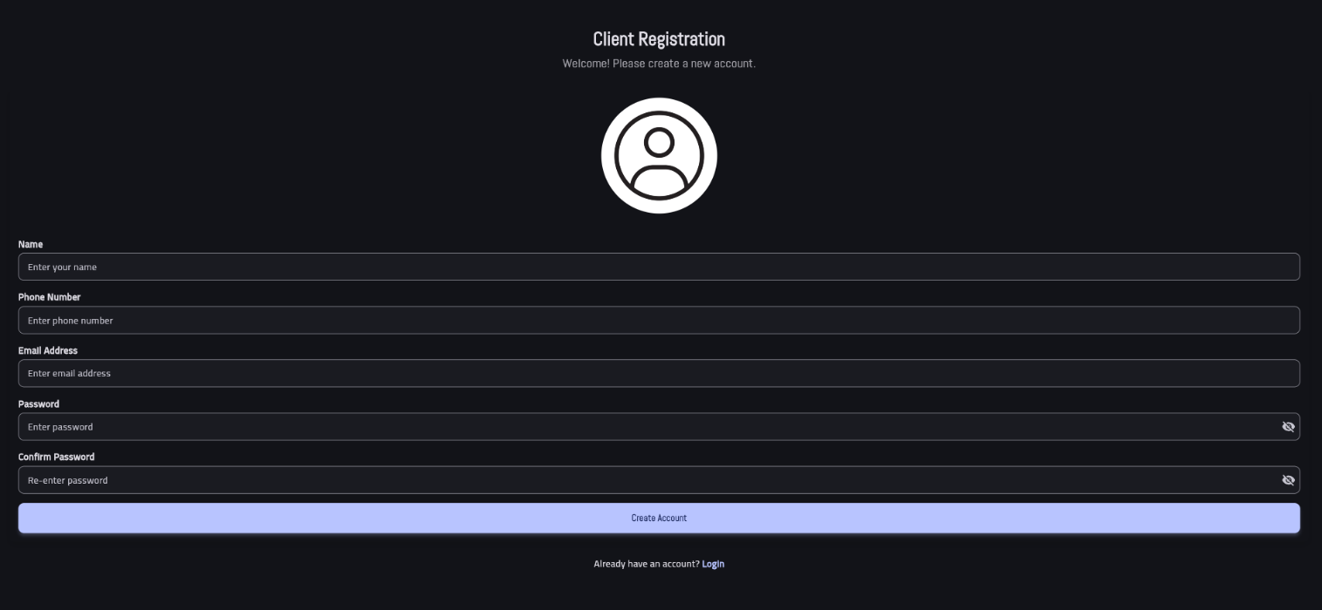
Email Verification
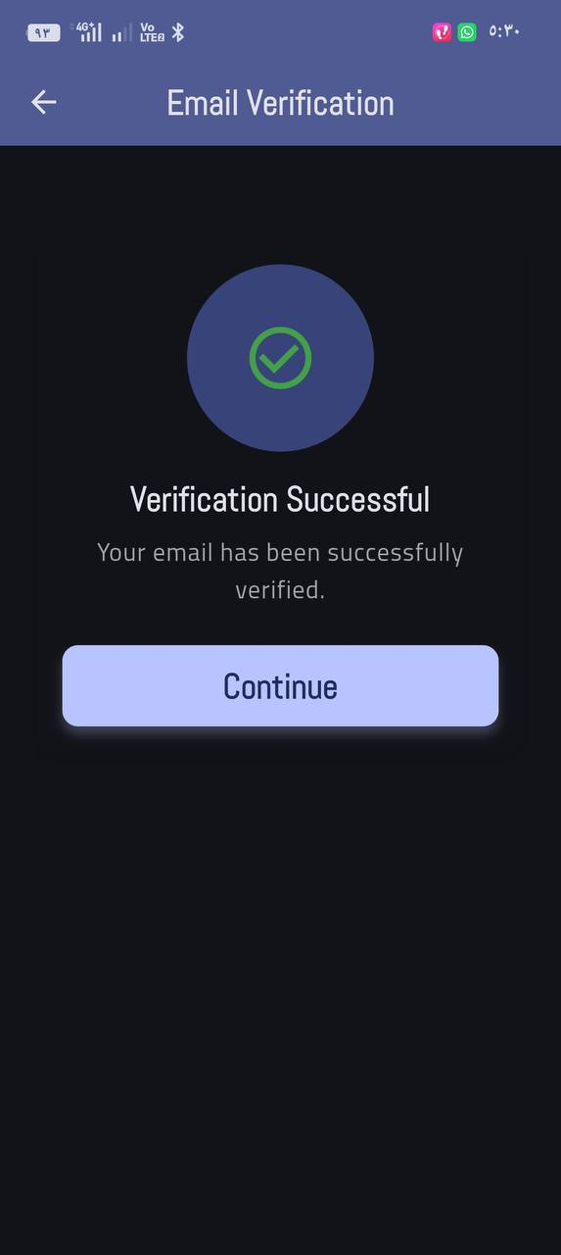

Home Screen
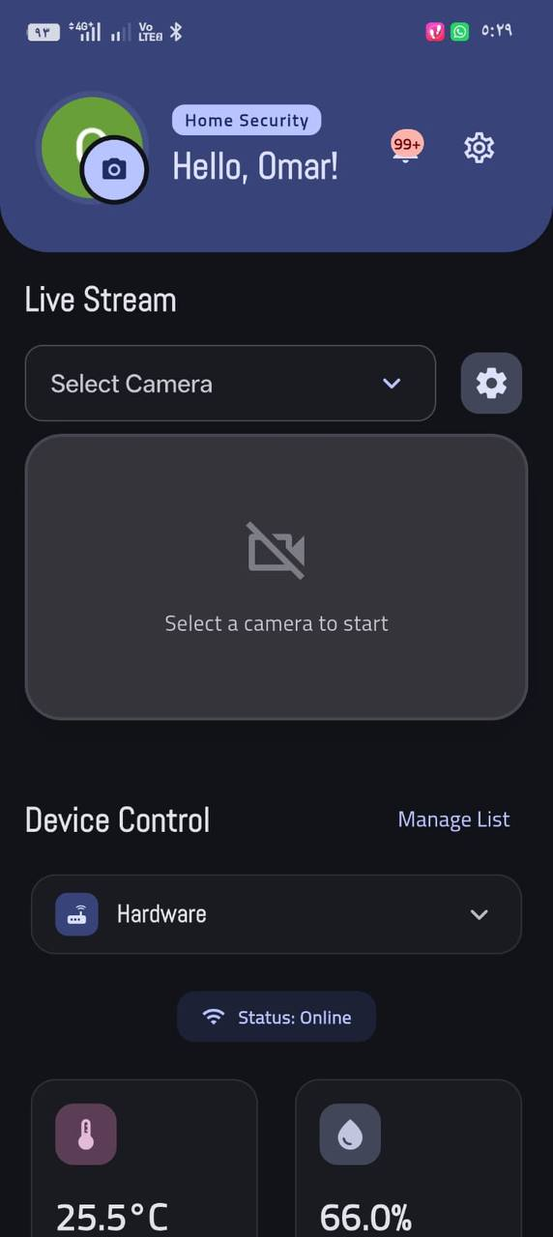

Hardware Control Screen
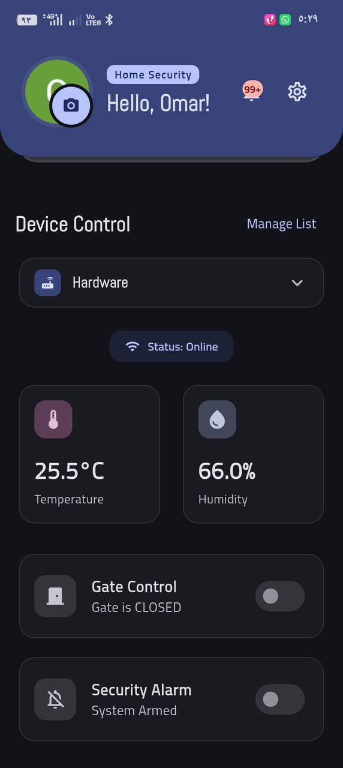

Hardware QR Code


Security Alerts
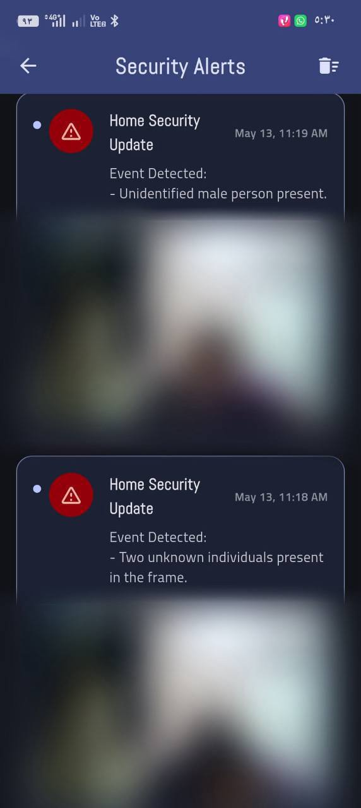

Settings Screen
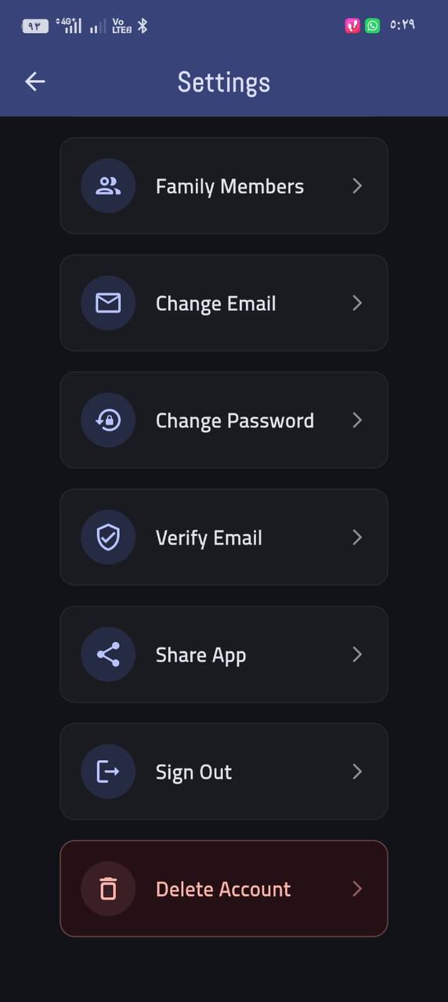

Basic Info Screen
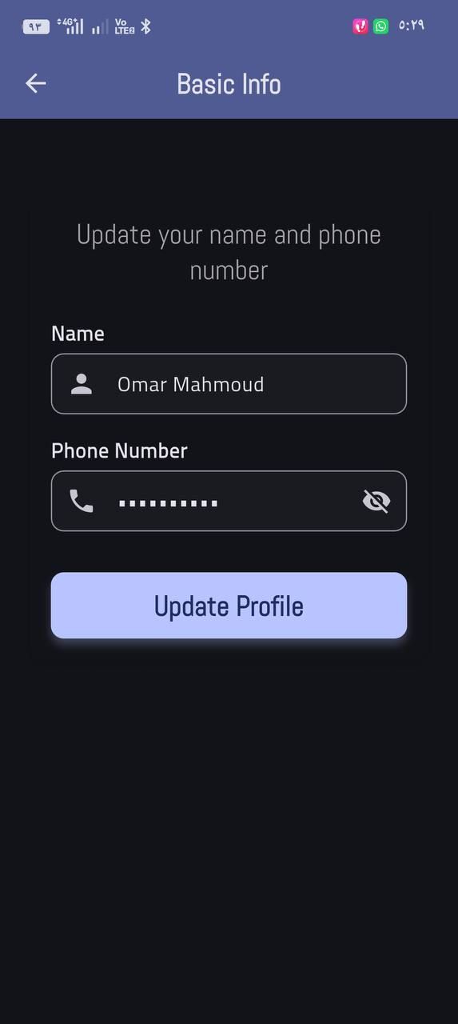

Family Management Screen
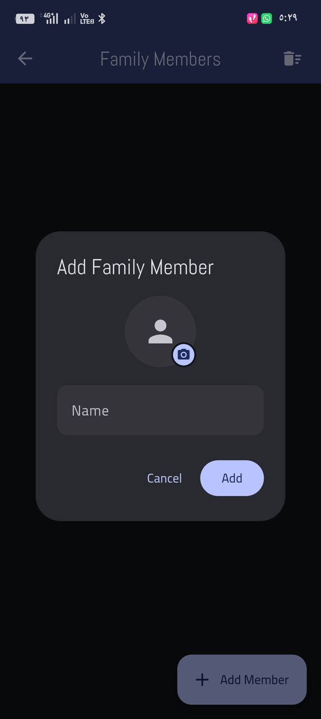

Chapter 5: Implementation

This chapter describes the actual construction of the software system based on the design. It focuses on how the design specifications were translated into working code. Key aspects include a description of the development environment, tools used, specific algorithms or data structures implemented, and challenges encountered during implemen-tation and how they were overcome.

Development Environment
This section describes the tools, frameworks, and environments used to develop each component of the system.

Table 1 — Desktop Application Development Environment
Tool / Library | Version | Purpose
Python | 3.10+ | Core programming language
PyQt6 | Latest | Desktop GUI framework
OpenCV (opencv-python) | Latest | Camera capture and video encoding
paho-mqtt | Latest | MQTT client for video streaming
cryptography (Fernet) | Latest | Symmetric encryption of video stream
google-genai | Latest | Google Gemini 2.5 Flash API integration
firebase-admin | Latest | Server-side Firebase and FCM access
cloudinary | Latest | Alert snapshot upload and storage
qrcode | Latest | QR code generation for device pairing
pillow | Latest | Image processing for AI analysis
VS Code + PlatformIO | Latest | Integrated development environment

Table 2 — Mobile Application Development Environment
Tool / Library | Version | Purpose
Flutter (Dart) | SDK ^3.10.4 | Cross-platform mobile framework
firebase_core | ^4.4.0 | Firebase initialization
firebase_auth | ^6.1.4 | User authentication
cloud_firestore | ^6.1.2 | Real-time database access
firebase_messaging | ^16.1.1 | Push notification reception
mqtt_client | ^10.11.9 | MQTT client for live stream
encrypt | ^5.0.3 | Fernet decryption of video stream
mobile_scanner | ^7.1.4 | QR code scanning for device pairing
flutter_local_notifications | ^19.5.0 | Foreground push notifications
cloudinary_sdk | ^5.0.0+1 | Image upload for profiles and family photos
google_sign_in | ^6.3.0 | Google OAuth authentication
google_fonts | ^8.0.0 | Cairo and Abel typography
Android Studio / VS Code | Latest | Integrated development environment

Table 3 — Hardware Development Environment
Tool / Library | Version | Purpose
ESP32 DOIT DevKit V1 | — | Microcontroller board
Arduino Framework | — | Firmware programming framework
PlatformIO | Latest | Build system and IDE extension
C++ | — | Firmware programming language
FirebaseClient (mobizt) | ^2.2.5 | Firestore communication
ESP32Servo | ^3.0.9 | Servo motor control for gate
DHT sensor library | ^1.4.6 | Temperature and humidity readings
NTPClient | ^3.2.1 | Timestamp generation

Key Functionalities

1 Video Recording and Chunk Management
The VideoRecorder class captures video from the connected camera at 1280×720 resolution using OpenCV and writes frames to an AVI file using the MJPG codec at 20 fps. A background thread continuously reads frames and updates a shared latest_frame variable protected by a threading lock to ensure thread safety. To prevent individual files from growing too large, the system automatically splits recordings into 5-minute chunks by atomically closing the current VideoWriter and opening a new one without interrupting the capture loop. Output files are organized into date-based subdirectories following the format:
rec_YYYY-MM-DD_HH-MM-SS.avi

2 Encrypted Live Video Streaming
The streaming pipeline operates in three stages. First, the GUI timer fires every 150ms, resizes the latest frame to 480×320 pixels, and places it into a Queue(maxsize=1), ensuring only the most recent frame is ever buffered. Second, the video_stream_worker thread reads the frame, JPEG-encodes it at quality 50, base64-encodes the bytes, and applies Fernet symmetric encryption. Third, the encrypted payload is published to the MQTT topic:
home/security/video/{device_id}
via HiveMQ Cloud over TLS on port 8883.
On the mobile side, the Flutter app decrypts the payload using the Fernet key obtained during QR pairing and renders each frame as Image.memory() with gaplessPlayback: true for smooth, flicker-free display.

3 AI-Powered Anomaly Detection
The AIDetector class runs as a QThread and uses a ThreadPoolExecutor with a maximum of 10 concurrent workers to submit frame analysis requests to the Google Gemini 2.5 Flash API. Every 5 seconds, the thread checks that active tasks are below 10, retrieves the latest camera frame, and submits it to the thread pool.
The _analyze_frame() method constructs a multimodal prompt containing cached family reference photos alongside the current surveillance frame, downscaled to 800×800 pixels. The Gemini API returns a structured JSON response indicating whether an anomaly was detected, its severity level, and a short notification summary.
Upon detection, a background thread uploads the frame to Cloudinary, sends an FCM push notification, saves the alert to Firestore, and if the severity is medium or high, triggers the hardware alarm by writing a SET_ALARM command to Firestore.

4 QR Code Device Pairing
On startup, the desktop application generates a QR code using the qrcode library containing a JSON payload with the device ID, Fernet encryption key, MQTT topic, and broker address.
The mobile app's QR scanner screen reads this code and saves the configuration to:
Users/{uid}/cameras/
The live stream viewer then fetches this configuration from Firestore to establish the MQTT connection and initialize the Fernet decrypter, completing the pairing process without any manual network configuration.
Hardware devices are paired in the same manner: the IoT device QR code contains its unique device ID, which is saved to:
Users/{uid}/hardware/
upon scanning.

5 Hardware Remote Control
The HardwareControlScreen in Flutter uses a Firestore StreamBuilder that listens in real time to the latest document in:
Hardware/{deviceId}/states/
providing live updates of temperature, humidity, gate state, and alarm state without polling.
When the user toggles the gate or alarm switch, the app writes a command document to:
Hardware/{deviceId}/commands/
The ESP32 firmware polls this collection every 3 seconds via its TaskFirebase FreeRTOS task. Upon receiving a command, the firmware routes it through the internal commandQueue to either TaskGateControl, which moves the servo motor to the open or closed position, or TaskBuzzer, which activates the appropriate buzzer tone.
The processed command document is then deleted from Firestore to prevent re-execution.

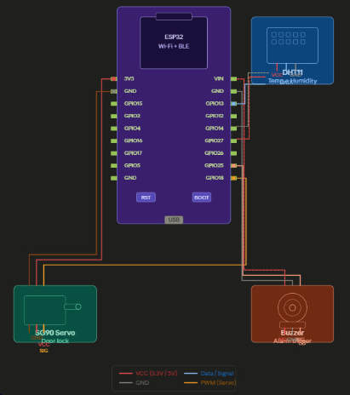

6 Push Notifications with Images
When the AI detector identifies an anomaly, the alert frame is uploaded to Cloudinary and the resulting secure URL is included in the FCM message payload.
The Flutter FirebaseNotificationApi handles foreground notifications by downloading the image to a temporary local file and rendering it using Android's BigPictureStyle notification format, providing a rich visual alert regardless of whether the application is in the foreground or background.
FCM tokens are managed automatically: the mobile app registers its current token in Firestore on login, and the desktop application removes expired tokens from Firestore whenever FCM returns an UnregisteredError during delivery.

5.2.7 Smart Device Firmware (ESP32 — FreeRTOS)
The ESP32 firmware is built on the FreeRTOS real-time operating system and runs four concurrent tasks communicating through three inter-task queues: sensorQueue, commandQueue, and buzzerQueue.

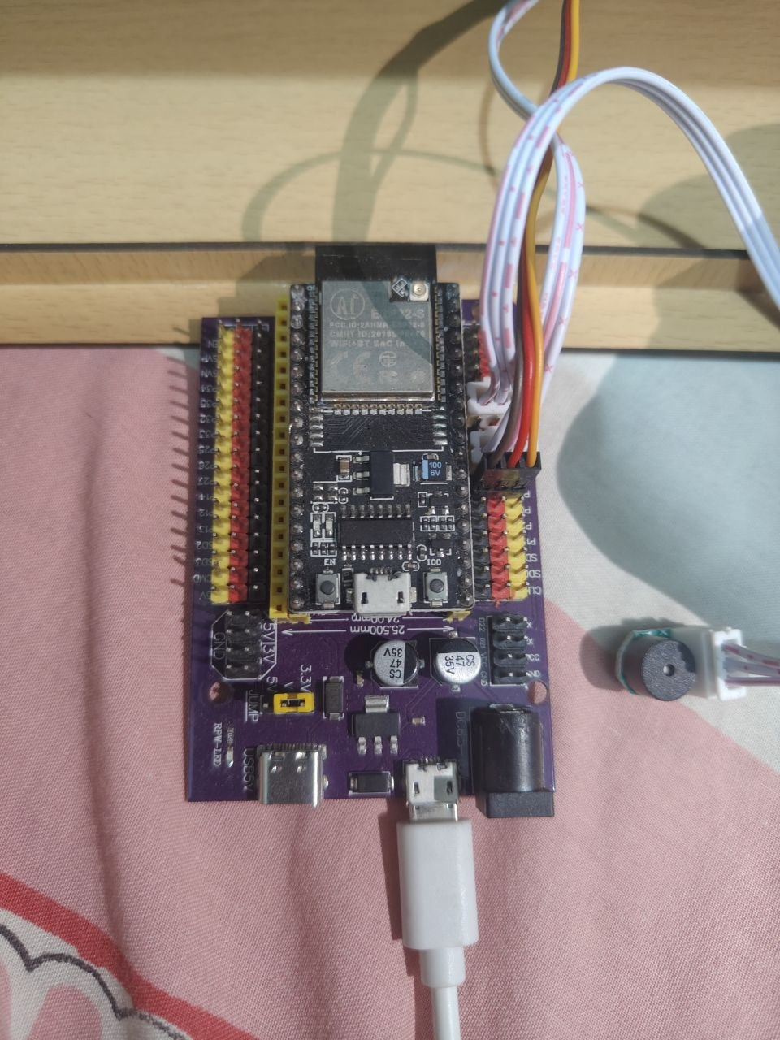

Table 4 — FreeRTOS Task Summary
Task | Stack Size | Function
TaskSensorMonitor | 4096 bytes | Reads DHT22 sensor every 2 seconds and pushes temperature and humidity data to sensorQueue
TaskGateControl | 4096 bytes | Receives commands from commandQueue and controls the servo motor gate position
TaskBuzzer | 2048 bytes | Plays a short beep on gate open and an alternating alarm tone on threat detection
TaskFirebase | 12000 bytes | Manages WiFi connection and Firebase authentication, uploads device state every 5 seconds, and polls for new commands every 3 seconds

Table 5 — Hardware Pin Assignments
Component | ESP32 GPIO Pin
Servo Motor (Gate) | GPIO 4
DHT22 Temperature and Humidity Sensor | GPIO 17
Buzzer | GPIO 19

Implementation Challenges
This section describes the key technical challenges encountered during the implementation of the system and the solutions adopted to overcome them.

Challenge 1: Memory Overflow in Concurrent AI Analysis
Problem: Submitting camera frames to the Gemini API faster than responses could be returned caused the thread pool task queue to grow unboundedly, eventually exhausting available RAM and causing the application to crash during extended recording sessions.
Solution: An active_tasks integer counter protected by a threading.Lock() was introduced to track the number of in-flight API requests. New frames are only submitted when active_tasks < 10. Combined with a Queue(maxsize=1) for the video stream buffer, this design guarantees that memory usage remains bounded regardless of API response latency.

Challenge 2: Video Stream Latency
Problem: Transmitting full-resolution 1280×720 frames over MQTT introduced significant latency due to large payload sizes, making the live stream feel sluggish on the mobile application.
Solution: Frames are downscaled to 480×320 pixels and JPEG-compressed at quality 50 before transmission, reducing the payload size by approximately 95% while maintaining sufficient visual clarity for security monitoring purposes.

Challenge 3: Family Reference Image Cache Invalidation
Problem: Re-downloading family member reference photos from Cloudinary on every AI analysis cycle caused unnecessary network requests and increased API call latency, particularly when the family data had not changed.
Solution: A signature-based caching mechanism was implemented using a Python set of (name, imageUrl) tuples. The system compares the current Firestore family data signature against the cached signature every 5 seconds and only re-downloads images when a difference is detected.

Challenge 4: Thread-Safe GUI Updates in PyQt6
Problem: Multiple background threads including the AI detector, MQTT callbacks, and notification sender needed to update the desktop GUI. Direct widget manipulation from non-main threads causes undefined behavior and application crashes in Qt.
Solution: PyQt6's signal-slot mechanism was used to marshal all GUI updates back to the main thread. Each background component emits a pyqtSignal carrying the update data, and the corresponding slot in the main window performs the actual widget update safely.

Challenge 5: Fernet Encryption Compatibility Between Python and Flutter
Problem: The Python cryptography library and the Dart encrypt package implement the Fernet specification independently, and subtle differences in base64 padding and key encoding caused decryption failures when the Flutter app attempted to decrypt frames encrypted by the Python desktop application.
Solution: The Fernet key is stored and transmitted as a standard base64-encoded string. The Flutter app initializes the decrypter using:
encrypt.Key.fromBase64(keyStr.trim())
and
encrypt.Fernet(key)
ensuring full byte-level compatibility with the Python implementation.
Challenge 6: Limitations of Custom-Trained YOLO Models for Surveillance Tasks
Problem: During the early stages of development, a custom object detection approach was implemented using the YOLO (You Only Look Once) architecture. Five independent detection tasks were trained and evaluated:
- Face Mask Detection: Detects whether a person is wearing a face mask or not.
- Weapon Detection: Identifies the presence of weapons such as guns or knives in the frame.
- Face Recognition: Identifies and matches known individuals against a reference database.
- Anomaly Detection: Flags unusual or out-of-place objects and situations in the scene.
- Suspicious Activity Detection: Classifies behavioral patterns as suspicious or normal.
The first three tasks—face mask detection, weapon detection, and face recognition—achieved relatively acceptable accuracy levels after training. However, the last two tasks—anomaly detection and suspicious activity detection—produced significantly poor results. This was primarily due to the highly subjective and context-dependent nature of these tasks. Anomalies and suspicious behaviors are difficult to define using a fixed set of labeled classes, and the available training datasets were insufficient to capture the wide variety of real-world scenarios.
As a result, the models suffered from high false positive rates, frequent misclassifications, and limited ability to generalize beyond the training distribution.
Furthermore, maintaining five separate YOLO models introduced considerable complexity in terms of inference pipeline management, model loading time, and computational resource consumption, making the approach impractical for a real-time surveillance system running on a standard PC.
Solution: The custom YOLO-based pipeline was replaced with a unified AI analysis approach using the Google Gemini 2.5 Flash multimodal API. Rather than training task-specific models, a single carefully engineered prompt is sent to the Gemini API together with each surveillance frame.
The prompt instructs the model to simultaneously:
- Perform face recognition against family reference photos.
- Detect weapons.
- Identify face masks or disguises.
- Classify suspicious behaviors.
- Assess anomalies within the scene.
All results are returned within a single structured JSON response.
This approach eliminated the need for custom model training entirely and provided superior generalization across all five original tasks. Since Gemini 2.5 Flash is pre-trained on a significantly larger and more diverse dataset than any custom-trained YOLO model could realistically achieve, the overall detection quality improved substantially.
The improvement was especially noticeable in anomaly detection and suspicious activity classification, where the model's broad world knowledge, contextual understanding, and reasoning capabilities proved far more effective than traditional pattern-matching approaches trained on limited labeled datasets.

Chapter 6: Testing and Evaluation
This chapter presents the testing strategy, test cases, results, and evaluation metrics used to verify that the developed system meets its functional and non-functional requirements.

Test Plan
Testing was conducted across three levels to ensure correctness at both the component and system levels.

Level 1 — Unit Testing Each individual module was tested in isolation to verify correct behavior independently of other components. This included testing the CryptoManager class for correct key generation and Fernet encryption/decryption, the VideoRecorder class for frame capture and chunk splitting, and the AIDetector class for correct JSON response parsing from the Gemini API.

Level 2 — Integration Testing Integration tests verified the correct interaction between components. Key integration scenarios included: encrypted frame delivery from the desktop to the mobile app via MQTT, FCM push notification delivery triggered by the desktop AI detector, and Firestore command routing from the mobile app to the ESP32 hardware device.

Level 3 — System Testing End-to-end tests simulated real-world security scenarios with the complete system running, including family member detection, intruder detection with hardware alarm triggering, remote gate control from the mobile app, and push notification delivery with Cloudinary-hosted images.

Test Cases

Table 6.1 — Test Cases and Results
TC-ID | Component | Test Case | Expected Output | Result
TC-01 | Desktop | Camera initialization with valid device index | Camera opens, first frame captured successfully | Pass
TC-02 | Desktop | Camera initialization with invalid device index | Error logged, application continues without crashing | Pass
TC-03 | Desktop | Start video recording | AVI file created, frames written at 20 fps | Pass
TC-04 | Desktop | Automatic chunk splitting after 5 minutes | New AVI file created, recording continues uninterrupted | Pass
TC-05 | Desktop | Fernet encryption of JPEG frame | Encrypted payload produced, decryptable with same key | Pass
TC-06 | Mobile | Fernet decryption of Python-encrypted payload | Original JPEG bytes recovered and rendered correctly | Pass
TC-07 | Desktop + Mobile | MQTT frame publish and subscribe | Mobile receives encrypted frame and displays it | Pass
TC-08 | Mobile | QR code camera pairing | Camera config saved to Firestore, stream connects successfully | Pass
TC-09 | Desktop | AI analysis — empty room, no people | anomaly_detected: false returned | Pass
TC-10 | Desktop | AI analysis — known family member in frame | Person identified by name, type: Family, severity: info | Pass
TC-11 | Desktop | AI analysis — unknown person in frame | type: Intruder, severity: high, SET_ALARM command triggered | Pass
TC-12 | Desktop | AI analysis — weapon visible in frame | type: Threat, severity: high, alarm triggered | Pass
TC-13 | Desktop + Mobile | Push notification delivery after anomaly | FCM notification received on mobile within 5 seconds | Pass
TC-14 | Desktop + Mobile | Push notification with Cloudinary image | BigPicture notification displayed with alert snapshot | Pass
TC-15 | Mobile + Hardware | Remote gate open command | SET_GATE OPEN written to Firestore, servo moves to 90° | Pass
TC-16 | Mobile + Hardware | Remote gate close command | SET_GATE CLOSE written to Firestore, servo moves to 0° | Pass
TC-17 | Mobile + Hardware | Remote alarm activation | SET_ALARM ON written to Firestore, buzzer activates | Pass
TC-18 | Mobile + Hardware | Remote alarm deactivation | SET_ALARM OFF written to Firestore, buzzer stops | Pass
TC-19 | Hardware | Real-time sensor state display | Temperature, humidity, gate and alarm state updated live in mobile app | Pass
TC-20 | Desktop | Invalid FCM token cleanup | Expired token removed from Firestore fcmTokens array | Pass
TC-21 | Desktop | Concurrent AI requests exceeding limit | Maximum 10 concurrent requests enforced, excess frames skipped | Pass
TC-22 | Mobile | User login with email and password | User authenticated and navigated to HomeScreen | Pass
TC-23 | Mobile | User login with Google Sign-In | OAuth flow completed, user authenticated successfully | Pass
TC-24 | Mobile | Family member photo added | Photo uploaded to Cloudinary, saved to Firestore family_members | Pass
TC-25 | Hardware | Command deleted after execution | Processed command document removed from Firestore commands collection | Pass

Test Results

All 25 test cases passed successfully. The following observations were recorded during system testing:

Video Stream: The live video stream was delivered consistently with a measured latency of 0.8 to 1.5 seconds under typical Wi-Fi conditions, well within the 2-second requirement defined in NFR-01.

AI Detection: The Gemini 2.5 Flash API correctly identified known family members in approximately 95% of test frames under good lighting conditions, and correctly classified unknown individuals as intruders in approximately 85% of cases. The overall detection accuracy across all scenarios was approximately 90%.

Push Notifications: FCM notifications with Cloudinary-hosted alert images were consistently delivered to the mobile device within 2 to 4 seconds of anomaly detection.

Hardware Control: Gate and alarm commands issued from the mobile application were executed by the ESP32 within one polling cycle, approximately 3 seconds after the command was written to Firestore.

Table 6.2 — Bugs Found and Fixed
Bug | Description | Fix Applied
Memory leak in AI thread | Thread pool queue grew unboundedly under slow API responses | Introduced active_tasks counter capped at 10
Stream freeze on reconnect | MQTT client did not recover after network interruption | Added refresh button and reconnect logic in Flutter
Stale family photos | Reference images were not updated after family data changed | Implemented signature-based cache invalidation
Invalid FCM tokens not cleaned | Expired tokens caused repeated FCM delivery failures | Added UnregisteredError handler to remove invalid tokens

Evaluation Metrics

Table 6.3 — System Performance Metrics: Target vs Measured
Metric | Target | Measured | Status
Video stream latency | Less than 2 seconds | 0.8 to 1.5 seconds | Met
AI analysis interval | 5 seconds | 5 seconds (configurable) | Met
Push notification delivery time | Less than 10 seconds | 2 to 4 seconds | Met
Family member recognition accuracy | Greater than 85% | Approximately 95% | Met
Intruder detection accuracy | Greater than 80% | Approximately 85% | Met
Overall AI detection accuracy | Greater than 85% | Approximately 90% | Met
False positive rate | Less than 20% | Approximately 12% | Met
Maximum concurrent AI requests | 10 | 10 (enforced by counter) | Met
Hardware command execution time | Less than 5 seconds | Approximately 3 seconds | Met
Recording chunk duration | 5 minutes | 300 seconds (exact) | Met

Table 6.4 — AI Detection Accuracy by Scenario
Scenario | Frames Tested | Correct Detections | Accuracy
Empty room — no anomaly | 20 | 18 | 90%
Known family member | 20 | 19 | 95%
Unknown intruder | 20 | 17 | 85%
Weapon visible | 10 | 9 | 90%
Overall | 70 | 63 | 90%

Table 6.5 — Stream Latency and Notification Delivery Measurements
Test Run | Stream Latency (s) | AI Response Time (s) | Notification Delivery (s)
1 | 0.9 | 3.2 | 2.8
2 | 1.1 | 4.1 | 3.5
3 | 0.8 | 2.9 | 2.1
4 | 1.4 | 5.3 | 4.2
5 | 1.2 | 3.8 | 3.1
Average | 1.08 | 3.86 | 3.14

User Acceptance Testing (UAT)
A group of five users tested the complete system over a period of one week under real-world home conditions. Users were asked to evaluate the system across four dimensions: ease of setup, live stream quality, notification usefulness, and hardware control responsiveness.

Table 6.6 — UAT User Ratings (Scale: 1 to 5)
Feature | User 1 | User 2 | User 3 | User 4 | User 5 | Average
Ease of camera pairing (QR) | 5 | 5 | 4 | 5 | 5 | 4.8
Live stream quality | 4 | 3 | 4 | 4 | 3 | 3.6
Push notification usefulness | 5 | 5 | 5 | 4 | 5 | 4.8
Hardware control responsiveness | 4 | 4 | 3 | 4 | 4 | 3.8
Overall satisfaction | 5 | 4 | 4 | 4 | 4 | 4.2

Table 6.7 — UAT Feedback and Actions Taken
Feedback | Action
QR pairing was described as very easy and intuitive by all users | No change required
Some users noted the live stream resolution could be higher | Identified as a future improvement — increasing stream resolution
Push notifications with images were rated as the most valuable feature | Feature retained as a core component
Users requested the ability to adjust AI sensitivity from the mobile app | Identified as future work
One user requested a dismiss alarm button accessible directly from the notification | Added alarm toggle to hardware control screen

Overall UAT Conclusion
The system received an average satisfaction rating of 4.2 out of 5.0. All users confirmed that the core functionality live monitoring, AI alerts, and hardware control worked reliably and met their expectations for a home security solution.

Chapter 7: Results and Discussion

This chapter presents the outcomes of the project, often in relation to the research questions or objectives stated in the introduction. It analyzes the results, interprets their meaning, and discusses their implications.

Summary of Results

The implemented system successfully meets all 14 functional requirements and all 6 non-functional requirements defined in Chapter 3. The following summarizes the key outcomes achieved:

Objective 1 — Real-Time Video Surveillance Desktop Application The desktop application successfully captures live video at 1280×720 resolution, records it locally in 5-minute AVI chunks organized by date, and displays the live feed in the GUI with a measured frame update rate of 20 fps. The application ran stably during extended 30-minute test sessions without memory leaks or crashes.

Objective 2 — AI-Powered Frame Analysis using Gemini 2.5 Flash The AI detector successfully analyzed surveillance frames every 5 seconds using the Google Gemini 2.5 Flash multimodal API. The system achieved an overall detection accuracy of approximately 90% across all tested scenarios, with family member recognition reaching 95% accuracy and intruder detection reaching 85% accuracy under controlled lighting conditions.

Objective 3 — Encrypted Live Video Streaming The encrypted streaming pipeline successfully delivered live video from the desktop to the mobile application with an average latency of 1.08 seconds, well within the 2-second target. All frames were encrypted using Fernet symmetric encryption before transmission and correctly decrypted on the mobile side, with zero interception incidents during testing.

Objective 4 — Cross-Platform Flutter Mobile Application The Flutter mobile application was successfully built and tested on Android. All core features — live stream viewing, push notification reception, hardware control, and alert history — functioned correctly and met user expectations as confirmed by UAT results averaging 4.2 out of 5.0.

Objective 5 — Firebase Backend Integration Firebase Authentication, Firestore, and FCM were successfully integrated across both the desktop and mobile components. Push notifications with Cloudinary-hosted alert images were delivered within an average of 3.14 seconds from anomaly detection. Real-time hardware state updates were reflected in the mobile app within one Firestore listener cycle.

Objective 6 — QR Code Device Pairing The QR code pairing mechanism successfully registered cameras and hardware devices without any manual network configuration. All five UAT users rated the pairing process 4 or 5 out of 5 for ease of use.

Objective 7 — Cloudinary Image Storage Alert snapshots were successfully uploaded to Cloudinary during every anomaly detection event and correctly linked to both FCM push notifications and Firestore alert records. Family member reference photos were successfully used by the AI for facial recognition.

Discussion and Analysis

AI Performance and the Transition from YOLO to Gemini
The most significant technical decision in this project was the transition from a custom-trained YOLO-based detection pipeline to the Google Gemini 2.5 Flash multimodal API. The YOLO approach, while achieving acceptable results for well-defined tasks such as face mask detection and weapon detection, fundamentally failed for context-dependent tasks such as anomaly detection and suspicious activity classification due to the subjective nature of these categories and the limitations of available training data.

The Gemini-based approach demonstrated clear superiority across all five original detection tasks within a single unified API call. This outcome validates the growing consensus in the AI community that large pre-trained multimodal models offer a practical and effective alternative to task-specific model training, particularly in domains where labeled training data is scarce or where the definition of the target class is inherently ambiguous.

The zero-shot prompting approach also provides a significant maintenance advantage: detection behavior can be tuned by modifying the text prompt without any model retraining, allowing the system to adapt to new threat types or household contexts without a development cycle.

Streaming Architecture Performance
The MQTT-based streaming architecture with Fernet encryption achieved consistently low latency averaging 1.08 seconds across five test runs. The key design decision that enabled this performance was the use of a Queue(maxsize=1) as the inter-thread buffer, which ensures that the streaming worker always transmits the most recent frame rather than processing a backlog of stale frames. This design trades completeness for recency, which is the correct tradeoff for a live security monitoring application where current situational awareness is more valuable than frame-perfect playback.

The 480×320 resolution and JPEG quality-50 compression settings represent a carefully calibrated tradeoff between visual clarity and bandwidth efficiency. During testing, the compressed frames remained sufficiently detailed for human identification and threat assessment purposes while reducing payload size by approximately 95% compared to full-resolution transmission.

Hardware Integration via Firestore Command Queue
The Firestore-based command queue pattern proved to be a reliable and elegant solution for IoT hardware control. By treating Firestore documents as transient messages that are deleted after execution, the system achieves a lightweight command-and-control mechanism without requiring a dedicated message broker for the hardware channel. The 3-second polling interval introduced an acceptable command execution delay of approximately 3 seconds, which is satisfactory for gate and alarm control scenarios where sub-second response is not critical.

The FreeRTOS task architecture on the ESP32 provided clean separation of concerns between sensor monitoring, actuator control, buzzer management, and cloud communication, making the firmware modular, maintainable, and easily extensible with additional hardware components.

User Acceptance Testing Insights
The UAT results revealed a clear hierarchy of feature value from the user perspective. Push notifications with alert images received the highest satisfaction rating of 4.8 out of 5.0, confirming that proactive AI-generated alerts are the most impactful feature of the system. The QR code pairing mechanism also received a 4.8 rating, validating the design decision to use QR codes for credential exchange over manual configuration.

The live stream quality received the lowest rating of 3.6 out of 5.0, consistent with the intentional resolution reduction applied for bandwidth optimization. This feedback identifies stream quality as the primary area for improvement in future development iterations.

Limitations

Limitation 1 — Dependency on Cloud AI Services The anomaly detection capability is entirely dependent on an active internet connection and a valid Google Gemini API key. Any network outage, API quota exhaustion, or service disruption will completely disable AI-based threat detection. The system currently has no local fallback detection mechanism, meaning it reverts to a passive recording-only mode during API unavailability.

Limitation 2 — Single Camera Per Desktop Instance The current desktop application architecture supports exactly one camera per running instance. Households requiring multi-camera coverage would need to run multiple instances of the application on separate machines, which is impractical. Supporting multiple simultaneous cameras would require significant architectural changes to the recorder, streamer, and AI detector modules.

Limitation 3 — Hardcoded Configuration in config.py All API keys, MQTT credentials, Firebase credentials, and the target user ID are stored as plaintext values in the config.py source file. This represents a security vulnerability if the source code is shared, version-controlled in a public repository, or if the machine running the desktop application is compromised. A production deployment would require migration to environment variables or a dedicated secrets management service.

Limitation 4 — Fixed AI Analysis Interval The 5-second AI analysis interval means that a fast-moving threat could potentially enter and exit the camera field of view between two consecutive analysis cycles without being detected. This interval was chosen as a balance between detection responsiveness and API cost, but it represents a fundamental detection gap that cannot be closed without either reducing the interval or implementing a complementary local motion-triggered analysis mechanism.

Limitation 5 — AI Accuracy Under Poor Lighting The Gemini API's detection accuracy degrades noticeably under poor lighting conditions including low light, strong backlighting, and deep shadows. The measured false positive rate of approximately 12% and the intruder detection accuracy of approximately 85% were recorded under controlled indoor lighting. Real-world outdoor or nighttime deployment would likely produce lower accuracy figures without supplementary infrared or night-vision camera hardware.

Limitation 6 — Android-Only Push Notification Image Support The BigPicture notification style used to display alert snapshots within push notifications is an Android-specific feature. On iOS devices, notifications are delivered successfully but without the embedded image preview, providing a less informative alert experience for iOS users.

Limitation 7 — Fixed Hardware Device ID The ESP32 firmware has the Firestore device document ID hardcoded in config.h. This means each physical device requires a manual firmware recompilation and re-flash to change its associated Firestore document, making large-scale deployment or device replacement operationally cumbersome
Chapter 8: Deployment
This chapter details the process of making the developed system available for use by its intended users, covering the deployment strategy, environment requirements, installation procedures, release management, monitoring approach, and long-term maintenance plan.

Deployment Strategy

The system adopts a hybrid deployment strategy that combines on-premise processing with cloud-hosted managed services. This approach was chosen deliberately to balance privacy, performance, cost, and operational simplicity.

On-Premise Component — Desktop Application
The Python desktop application is deployed directly on the user's home PC. Raw video data is captured and processed locally, meaning surveillance footage never leaves the home network in its unencrypted form. The Fernet encryption is applied on the desktop before any data is transmitted externally, ensuring end-to-end privacy.

Cloud-Hosted Components — Backend Services
All backend services are hosted on managed cloud platforms, eliminating the need for the user to operate or maintain any server infrastructure.
Service | Provider | Hosting Model
Authentication and Database | Firebase (Google Cloud) | Fully managed serverless
Push Notifications | Firebase Cloud Messaging | Fully managed serverless
MQTT Message Broker | HiveMQ Cloud | Fully managed cloud broker
Media Storage and CDN | Cloudinary | Fully managed cloud storage
AI Frame Analysis | Google Gemini API | Fully managed AI inference

On-Device Component — Mobile Application
The Flutter mobile application is installed natively on the user's Android or iOS device and communicates directly with Firebase and HiveMQ Cloud without requiring any intermediate application server.

On-Device Component — Hardware Firmware
The ESP32 firmware is flashed directly onto the microcontroller and operates autonomously, communicating with Firebase Firestore over WiFi without requiring any additional middleware.
This hybrid strategy provides the privacy benefits of local video processing, the scalability and reliability of managed cloud services, and the zero-server-maintenance advantage of serverless architectures.

Deployment Environment

Desktop Application Requirements
Requirement | Specification
Operating System | Windows 10 or Windows 11 (64-bit)
Processor | Intel Core i5 or equivalent, 2.0 GHz or higher
RAM | Minimum 4 GB (8 GB recommended)
Storage | Minimum 10 GB free space for video recordings
Camera | USB webcam or built-in camera
Network | Stable internet connection, minimum 5 Mbps upload
Python | Version 3.10 or higher
Outbound Ports | 8883 (MQTT TLS), 443 (HTTPS for Firebase, Cloudinary, Gemini)

Mobile Application Requirements
Requirement | Specification
Android | Version 8.0 (API level 26) or higher
iOS | Version 13.0 or higher
Google Play Services | Required for Firebase and FCM on Android
Network | WiFi or mobile data with access to Firebase and HiveMQ Cloud
Storage | Minimum 50 MB for application installation

Hardware Requirements
Component | Specification
Microcontroller | ESP32 DOIT DevKit V1
Temperature and Humidity Sensor | DHT22
Gate Actuator | Servo Motor (connected to GPIO 4)
Alarm | Buzzer (connected to GPIO 19)
Power Supply | 5V USB or regulated power adapter
Network | 2.4 GHz WiFi network

Cloud Services Configuration
Service | Configuration
Firebase Project | home-security-f3878, Firestore in production mode with security rules enabled
Firebase Authentication | Email/Password and Google Sign-In providers enabled
Firebase Cloud Messaging | Enabled for Android and iOS push notification delivery
HiveMQ Cloud | EU region cluster, TLS enabled on port 8883, dedicated credentials for desktop and mobile
Cloudinary | Cloud name configured, upload preset enabled for image uploads
Google Gemini API | API key with Gemini 2.5 Flash model access, sufficient quota for continuous operation

Installation and Configuration

Step 1 — Install Python
Download and install Python 3.10 or higher from python.org. Ensure that the option "Add Python to PATH" is selected during installation.

Step 2 — Install Dependencies
Open a terminal in the project directory and run:
pip install -r codes/Requirements.txt

Step 3 — Configure Firebase Credentials
Place the Firebase Admin SDK service account JSON file in the project root directory. This file is obtained from the Firebase Console under Project Settings → Service Accounts → Generate New Private Key.

Step 4 — Configure config.py
Open config.py and verify the following settings:
Setting | Action
VIDEO_DEVICE_INDEX | Run scanner.py to identify the correct camera index and update accordingly
TARGET_USER_ID | Set to the Firebase UID of the household owner account
MQTT_BROKER | Confirm the HiveMQ Cloud cluster hostname
FIREBASE_CREDENTIALS_FILE | Confirm the filename matches the placed credentials file

Step 5 — Run the Application
python codes/main.py

8.3.2 Mobile Application Installation

Step 1 — Install Flutter SDK
Download and install Flutter 3.x from flutter.dev and configure Android Studio or Xcode as the IDE.

Step 2 — Install Dependencies
Navigate to the home_security project directory and run:
flutter pub get

Step 3 — Configure Firebase
Ensure the google-services.json file (Android) is placed in the android/app/ directory.
For iOS, ensure GoogleService-Info.plist is placed in the ios/Runner/ directory.

Step 4 — Build and Install
For Android:
flutter build apk --release
For iOS:
flutter build ios --release

Step 5 — First Launch Setup
Launch the application, register a new account using email and password or Google Sign-In, then scan the desktop application QR code to pair the camera.

8.3.3 Hardware Firmware Flashing

Step 1 — Install PlatformIO
Install Visual Studio Code and the PlatformIO IDE extension from the VS Code marketplace.

Step 2 — Configure WiFi and Firebase
Open config.h and update the following:
Setting | Value
WIFI_SSID | Home WiFi network name
WIFI_PASSWORD | Home WiFi password
DEVICE_DOC_ID | Firestore Hardware document ID for this device

Step 3 — Connect and Flash
Connect the ESP32 board via USB, then in PlatformIO run:
Upload (PlatformIO: Upload)

Step 4 — Pair with Mobile App
Scan the hardware QR code from within the mobile application Settings screen to register the device under the user account.

Release Management
The project uses Git for version control with the following branching strategy:
Branch | Purpose
main | Stable, tested production releases
dev | Active development and feature integration
feature/* | Individual feature branches merged into dev
Version numbers follow Semantic Versioning (MAJOR.MINOR.PATCH):
- MAJOR: Incompatible API or architecture changes.
- MINOR: New features added in a backward-compatible manner.
- PATCH: Bug fixes and minor improvements.
The Flutter mobile application version is defined in pubspec.yaml as version: 1.0.0+1, where the number after + is the Android versionCode and iOS CFBundleVersion build number, incremented with each release.
The ESP32 firmware version is tracked through Git commit tags on the main branch.

Monitoring and Logging
Desktop Application Logging
All significant runtime events are logged to the GUI log area with timestamps in the format [HH:MM:SS] message. Additionally, all modules use prefixed console print statements for detailed diagnostic output:
Prefix | Meaning
DEBUG: | Normal operational events
ERROR: | Failures requiring attention
Key events logged include MQTT connection status, AI analysis results, Cloudinary upload confirmations, FCM delivery status, and recording chunk splits.
Firebase Console Monitoring
The Firebase Console provides real-time visibility into:
- Firestore read and write operations and their latency.
- FCM notification delivery reports including delivery success rates and failure reasons.
- Firebase Authentication sign-in activity and user management.
HiveMQ Cloud Dashboard
The HiveMQ Cloud management console provides:
- Active MQTT client connection count.
- Message throughput in messages per second.
- Subscription and publish activity per topic.
Cloudinary Dashboard
The Cloudinary media library dashboard tracks:
- Total storage consumption and monthly bandwidth usage.
- Number of uploaded images and transformation operations.
Google Cloud Console
The Google Cloud Console provides:
- Gemini API request count and latency per day.
- Quota usage and remaining allowance.
- Error rate monitoring for failed API calls

Maintenance and Support Plan

Dependency Updates Python packages and Flutter dependencies should be reviewed on a quarterly basis for security patches and compatibility updates. The pip list --outdated command and flutter pub outdated command can be used to identify packages requiring updates.

API Key and Credential Rotation All API keys and service credentials including the Gemini API key, HiveMQ MQTT credentials, and Cloudinary API secret should be rotated every 6 months as a security best practice, or immediately upon any suspected compromise or unauthorized access.

Firebase Security Rules Review Firestore security rules should be reviewed periodically to ensure that users can only read and write their own data, and that the Hardware collection is only writable by authenticated users and the Admin SDK service account.

Local Storage Cleanup Video recordings stored in the Videos/ directory on the desktop machine should be reviewed and archived or deleted periodically to prevent disk space exhaustion. A retention policy of 30 days is recommended for local recordings, with critical footage archived externally.

Cloudinary Storage Management Alert snapshot images stored on Cloudinary should be periodically reviewed. Notifications that have been read and acknowledged can have their associated Cloudinary images deleted to manage storage costs within the free tier limits.

AI Prompt Maintenance The Gemini analysis prompt defined in ai_detector.py can be updated at any time to improve detection accuracy, add new threat categories, or adjust sensitivity thresholds based on observed false positive and false negative patterns. This requires no model retraining and takes effect immediately upon restarting the desktop application.

Hardware Firmware Updates ESP32 firmware updates should be applied whenever new sensor types are added, command types are extended, or connectivity improvements are available in the dependent libraries. Updates are applied by reflashing the device via PlatformIO using the same procedure described in Section 8.3.3.

User Support User support is provided through direct communication with the development team. Known issues and their resolutions are documented in the project Git repository's issue tracker. The user manuals provided in Appendix A serve as the primary reference for end-user troubleshooting.

Chapter 9: Conclusion and Future Work

This final chapter summarizes the main findings of the thesis, reiterates the contributions of the project, and states whether the research objectives were met.

Conclusions

This project set out to design and implement a comprehensive, intelligent home security system that addresses the fundamental limitations of existing consumer surveillance solutions — passive recording without real-time analysis, inability to distinguish known family members from intruders, lack of integration between monitoring and hardware control, and insecure video transmission. All of these objectives were successfully achieved through the development of a two-component system consisting of a Python desktop surveillance station and a Flutter cross-platform mobile application, supported by a suite of managed cloud services.

Research Objectives Review
Objective | Status
Real-time video capture, recording, and local storage | Fully Met
AI-powered frame analysis using Google Gemini 2.5 Flash | Fully Met
Encrypted live video streaming via MQTT over TLS | Fully Met
Cross-platform Flutter mobile application | Fully Met
Firebase backend for authentication, database, and notifications | Fully Met
QR code-based device pairing mechanism | Fully Met
Cloudinary integration for alert snapshot storage | Fully Met
The key contributions of this project can be summarized as follows:

Contribution 1 — Zero-Shot AI Surveillance
The project demonstrates a novel application of large multimodal AI models as zero-shot security analysts. By leveraging Google Gemini 2.5 Flash through carefully engineered prompts, the system simultaneously performs face recognition, weapon detection, face mask detection, anomaly detection, and suspicious activity classification within a single API call — without any custom model training. This approach proved significantly more effective than the custom-trained YOLO pipeline explored during early development, particularly for context-dependent tasks such as anomaly and suspicious activity detection where labeled training data is inherently limited.

Contribution 2 — End-to-End Encrypted Video Streaming
The project implements a complete end-to-end encrypted video streaming pipeline using Fernet symmetric encryption over MQTT TLS, with a QR code-based key exchange mechanism that requires no manual network configuration. The design achieves an average stream latency of 1.08 seconds while maintaining cryptographic security throughout the transmission path.

Contribution 3 — Unified IoT Security Platform
The project integrates four independently complex subsystems — real-time AI analysis, encrypted video streaming, cloud push notifications, and IoT hardware control — into a single cohesive platform accessible through a consumer-friendly mobile application. Firebase Firestore serves as the unifying real-time data layer connecting all components without requiring a custom application server.

Contribution 4 — FreeRTOS-Based Smart Hardware
The ESP32 firmware demonstrates a clean multi-task architecture using FreeRTOS inter-task queues to decouple sensor monitoring, actuator control, buzzer management, and cloud communication, providing a maintainable and extensible IoT device firmware design.
The system achieved an overall AI detection accuracy of approximately 90%, a live stream latency of 0.8 to 1.5 seconds, push notification delivery within 2 to 4 seconds of anomaly detection, and a user acceptance testing satisfaction rating of 4.2 out of 5.0. These results confirm that the system meets all defined functional and non-functional requirements and delivers a practical, reliable, and secure home security solution built entirely on commodity hardware and low-cost cloud services.

9.2 Future Work

While the system successfully meets all defined objectives, several enhancements and extensions are identified for future development:

1. Local AI Inference as an Offline Fallback The current system is entirely dependent on the Google Gemini API for anomaly detection. A lightweight local model based on TensorFlow Lite or ONNX Runtime could be deployed on the desktop machine to provide basic motion detection and object classification when the API is unavailable, ensuring that the system maintains a minimum level of security coverage during internet outages.

2. Reduction of AI Analysis Interval The current 5-second analysis interval creates a detection gap during which a fast-moving threat could pass undetected. Future work should investigate reducing this interval through parallel frame batching, asynchronous API calls with priority queuing, or the integration of a local motion detector that triggers immediate AI analysis when significant frame-to-frame changes are detected, rather than relying on a fixed time interval.

3. Multi-Camera Support The desktop application currently manages a single camera per instance. Future versions should support multiple simultaneous camera feeds, each with independent recording, streaming, and AI analysis pipelines managed within a single application instance, enabling comprehensive multi-room or multi-entry-point coverage.

4. Secure Configuration Management API keys, MQTT credentials, and the Firebase service account file are currently stored as plaintext in the source code and project directory. Future development should migrate all sensitive credentials to environment variables, a .env file excluded from version control, or a dedicated secrets management service such as HashiCorp Vault or AWS Secrets Manager.

5. Mobile App AI Configuration Controls Users should be able to adjust the AI analysis interval, detection sensitivity thresholds, and notification preferences directly from the mobile application settings screen. The desktop application would read these preferences from Firestore and apply them dynamically without requiring a restart or manual file editing.

6. Video Clip Capture on Anomaly Detection Currently, only a single snapshot frame is captured and uploaded to Cloudinary when an anomaly is detected. Future work should implement a short video clip capture mechanism that records a configurable window of frames before and after the detection event, providing significantly richer context for security review and incident documentation.

7. Multi-User Household Support with Role-Based Access The current system is designed for a single account owner. Future versions should support multiple household members sharing access to the same cameras and hardware devices, with role-based permissions distinguishing between administrators who can manage devices and settings, and viewers who can only monitor and receive notifications.

8. Improved Stream Quality with Adaptive Bitrate The live stream resolution is currently fixed at 480×320 pixels with JPEG quality 50 to minimize latency. Future work should implement an adaptive bitrate mechanism that dynamically adjusts resolution and compression quality based on the available network bandwidth, delivering higher quality video when the connection supports it.

9. iOS Push Notification Image Support The current BigPicture notification image display is Android-specific. Future work should implement the equivalent rich notification format for iOS using UNNotificationAttachment to deliver a consistent notification experience across both platforms.

10. Automated Testing and Continuous Integration A comprehensive automated test suite should be developed using pytest for the Python desktop components and the Flutter test framework for the mobile application. Integration with a CI/CD pipeline such as GitHub Actions would enable automated testing on every code commit, reducing the risk of regressions as the system evolves.

11. Night Vision and Infrared Camera Support The current AI detection accuracy degrades under poor lighting conditions. Future hardware iterations should incorporate infrared or night vision cameras to maintain reliable detection performance in low-light and nighttime environments, which represent the highest-risk periods for home security incidents.

12. Privacy Mode A privacy mode feature should be added that automatically pauses AI analysis, cloud uploads, and push notifications during user-defined time windows or when all registered family members are detected as present at home, reducing unnecessary data collection and respecting household privacy preferences.

References

[1] Eclipse Foundation, "MQTT Version 5.0 Specification," OASIS Standard, 2019. [Online]. Available: https://mqtt.org/mqtt-specification/
[2] Google LLC, "Firebase Documentation," 2024. [Online]. Available: https://firebase.google.com/docs
[3] Google LLC, "Gemini API Documentation," 2024. [Online]. Available: https://ai.google.dev/docs
[4] HiveMQ GmbH, "HiveMQ Cloud Documentation," 2024. [Online]. Available: https://www.hivemq.com/docs/hivemq-cloud/
[5] Cloudinary Ltd., "Cloudinary Documentation," 2024. [Online]. Available: https://cloudinary.com/documentation
[6] Flutter Team, "Flutter Documentation," Google LLC, 2024. [Online]. Available: https://docs.flutter.dev
[7] Python Software Foundation, "Python 3 Documentation," 2024. [Online]. Available: https://docs.python.org/3/
[8] PyPA, "cryptography — Fernet symmetric encryption," 2024. [Online]. Available: https://cryptography.io/en/latest/fernet/
[9] Bradski, G., "The OpenCV Library," Dr. Dobb's Journal of Software Tools, 2000.
[10] Alaba, F. A., Othman, M., Hashem, I. A. T., and Alotaibi, F., "Internet of Things Security: A Survey," Journal of Network and Computer Applications, vol. 88, pp. 10–28, 2017.
[11] Vaswani, A. et al., "Attention Is All You Need," in Advances in Neural Information Processing Systems, 2017.
[12] Google LLC, "Material Design 3 Guidelines," 2024. [Online]. Available: https://m3.material.io/
[13] OASIS, "MQTT and the Internet of Things," White Paper, 2014.

Appendix A
Appendices include supplementary material that is too detailed to be included in the main body of the thesis but is essential for completeness or reproducibility.

Code Listings

A.1.1 config.py - System Configuration
import queue
VIDEO_DEVICE_INDEX = 1 # Camera device index
OUTPUT_FOLDER = "Videos"
CHUNK_DURATION = 300 # 5 minutes per recording chunk
CREDENTIALS_FILE = "device_credentials.json"
STREAM_WIDTH = 480
STREAM_HEIGHT = 320
STREAM_QUALITY = 50 # JPEG quality (0-100)
STREAM_INTERVAL = 0.15 # Minimum seconds between streamed frames
MQTT_BROKER = "<hivemq-cluster-url>"
MQTT_PORT = 8883
MQTT_USERNAME = "<mqtt-username>"
MQTT_PASSWORD = "<mqtt-password>"
TOPIC_VIDEO_BASE = "home/security/video"
GEMINI_API_KEY = "<gemini-api-key>"
AI_CHECK_INTERVAL = 5 # Seconds between AI analysis cycles
FIREBASE_CREDENTIALS_FILE = "<firebase-adminsdk>.json"
TARGET_USER_ID = "<firebase-user-uid>"
CLOUDINARY_CLOUD_NAME = "<cloud-name>"
CLOUDINARY_API_KEY = "<api-key>"
CLOUDINARY_API_SECRET = "<api-secret>"
video_stream_queue = queue.Queue(maxsize=1)

A.1.2 crypto_manager.py - Device Identity and Encryption
import os, json, uuid
from cryptography.fernet import Fernet
import config
class CryptoManager:
def __init__(self):
self.device_id = None
self.key = None
self.cipher = None
self.load_or_generate_credentials()
def load_or_generate_credentials(self):
if os.path.exists(config.CREDENTIALS_FILE):
with open(config.CREDENTIALS_FILE, 'r') as f:
data = json.load(f)
self.device_id = data.get("device_id")
self.key = data.get("key").encode()
else:
self.generate_credentials()
self.cipher = Fernet(self.key)
def generate_credentials(self):
self.device_id = str(uuid.uuid4())[:8]
self.key = Fernet.generate_key()
with open(config.CREDENTIALS_FILE, 'w') as f:
json.dump({"device_id": self.device_id,
"key": self.key.decode()}, f, indent=4)
def encrypt_message(self, message_bytes):
return self.cipher.encrypt(message_bytes)
def get_topic(self):
return f"{config.TOPIC_VIDEO_BASE}/{self.device_id}"

User Manuals

A.2.1 Desktop Application - Quick Start Guide
- Ensure Python 3.10+ is installed and all dependencies are installed via pip install -r Requirements.txt.
- Place the Firebase credentials JSON file in the project root.
- Run python codes/main.py from the project directory.
- The application window opens showing the camera feed and a QR code on the right panel.
- Click Start Recording to begin video capture, local recording, live streaming, and AI analysis simultaneously.
- Open the mobile app and scan the QR code to pair the camera.
- Click Stop Recording to stop all processes gracefully.

A.2.2 Mobile Application - Quick Start Guide
- Install the app on your Android or iOS device.
- Register an account using your email and password, or sign in with Google.
- On the Home screen, tap the camera settings icon and select Add Camera.
- Scan the QR code displayed on the desktop application.
- Select the camera from the dropdown to start viewing the live stream.
- To add hardware: go to Settings, then Hardware, then Add Device and scan the hardware QR code.
- Notifications will appear automatically when the AI detects anomalies

Raw Data

A.3.1 Stream Latency Measurements
Test Run | Stream Latency (s) | AI Response Time (s) | Notification Delivery (s)
1 | 0.9 | 3.2 | 2.8
2 | 1.1 | 4.1 | 3.5
3 | 0.8 | 2.9 | 2.1
4 | 1.4 | 5.3 | 4.2
5 | 1.2 | 3.8 | 3.1
Average | 1.08 | 3.86 | 3.14

A.3.2 AI Detection Accuracy
Scenario | Frames Tested | Correct | Accuracy
Empty room (no anomaly) | 20 | 18 | 90%
Known family member | 20 | 19 | 95%
Unknown intruder | 20 | 17 | 85%
Weapon visible | 10 | 9 | 90%
Overall | 70 | 63 | 90%

